Symmetrical Arrangement

Definition
# Source: AI Source: Provided by: [Data Path: Persons Table -> ID Column: 1, Name_En Column: Motasem Essam] -> From: [ChatGPT] on [7/25/2026]
A Symmetrical Arrangement is a type of composite solid arrangement in which two or more solid components are positioned according to a symmetrical pattern relative to a common reference, such as a plane, line, point, or axis.
The components are distributed so that corresponding parts have matching positions, shapes, dimensions, or orientations according to the chosen symmetry.
A symmetrical arrangement may contain identical or different solid components, provided that their overall configuration satisfies the relevant symmetry condition.

Simple Definition
# Source: AI Source: Provided by: [Data Path: Persons Table -> ID Column: 1, Name_En Column: Motasem Essam] -> From: [ChatGPT] on [7/25/2026]
A symmetrical arrangement is a composite solid in which components are positioned in a balanced, matching pattern around a central plane, axis, or point.

Geometric Representation
# Source: AI Source: Provided by: [Data Path: Persons Table -> ID Column: 1, Name_En Column: Motasem Essam] -> From: [ChatGPT] on [7/25/2026]
Symmetrical arrangements can be constructed using cubes, rectangular prisms, cylinders, cones, pyramids, spheres, or combinations of different solids.
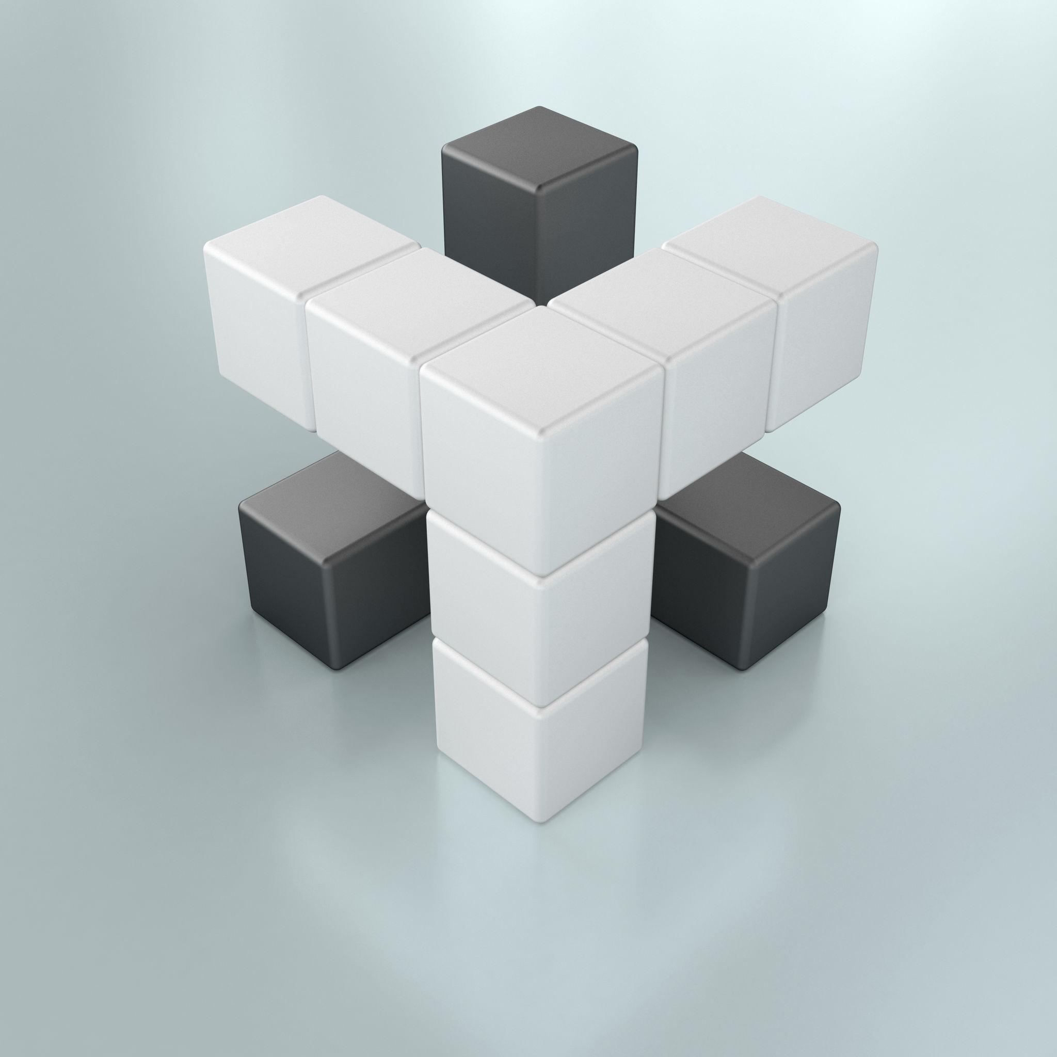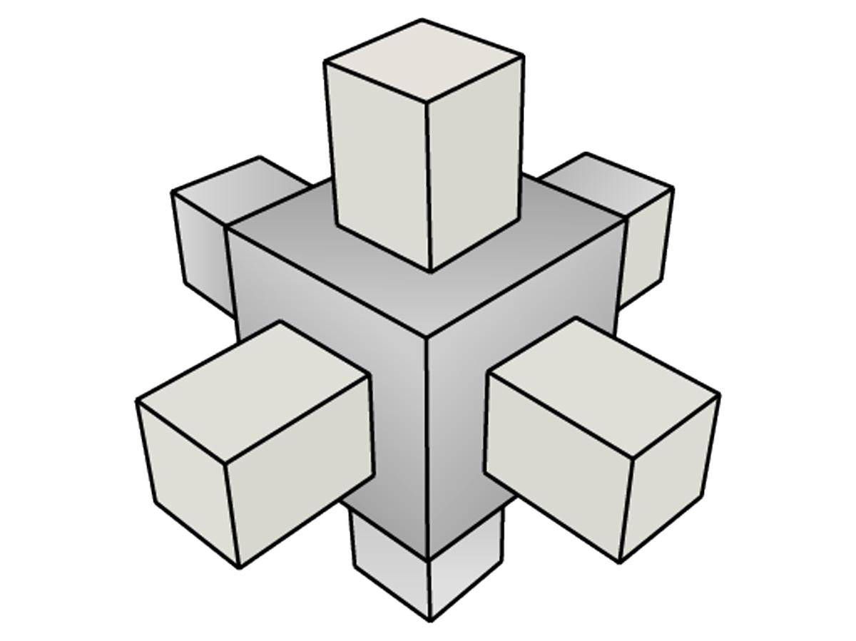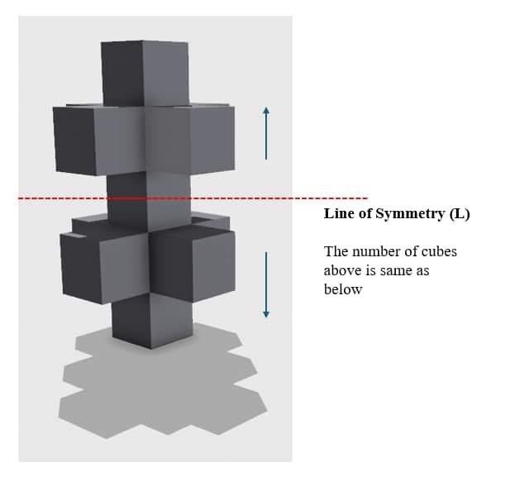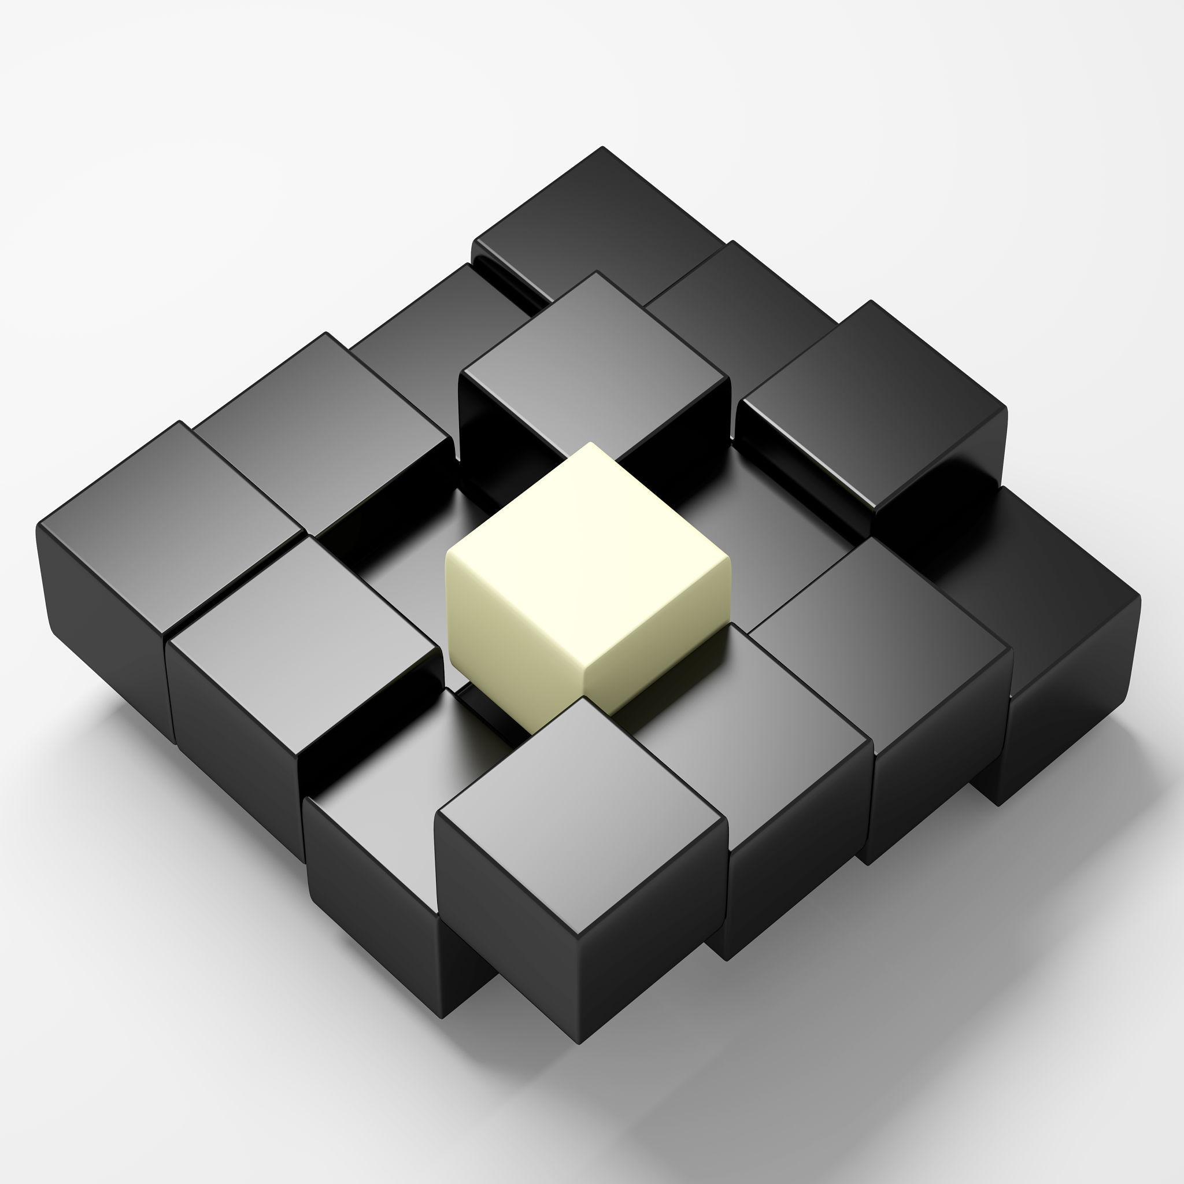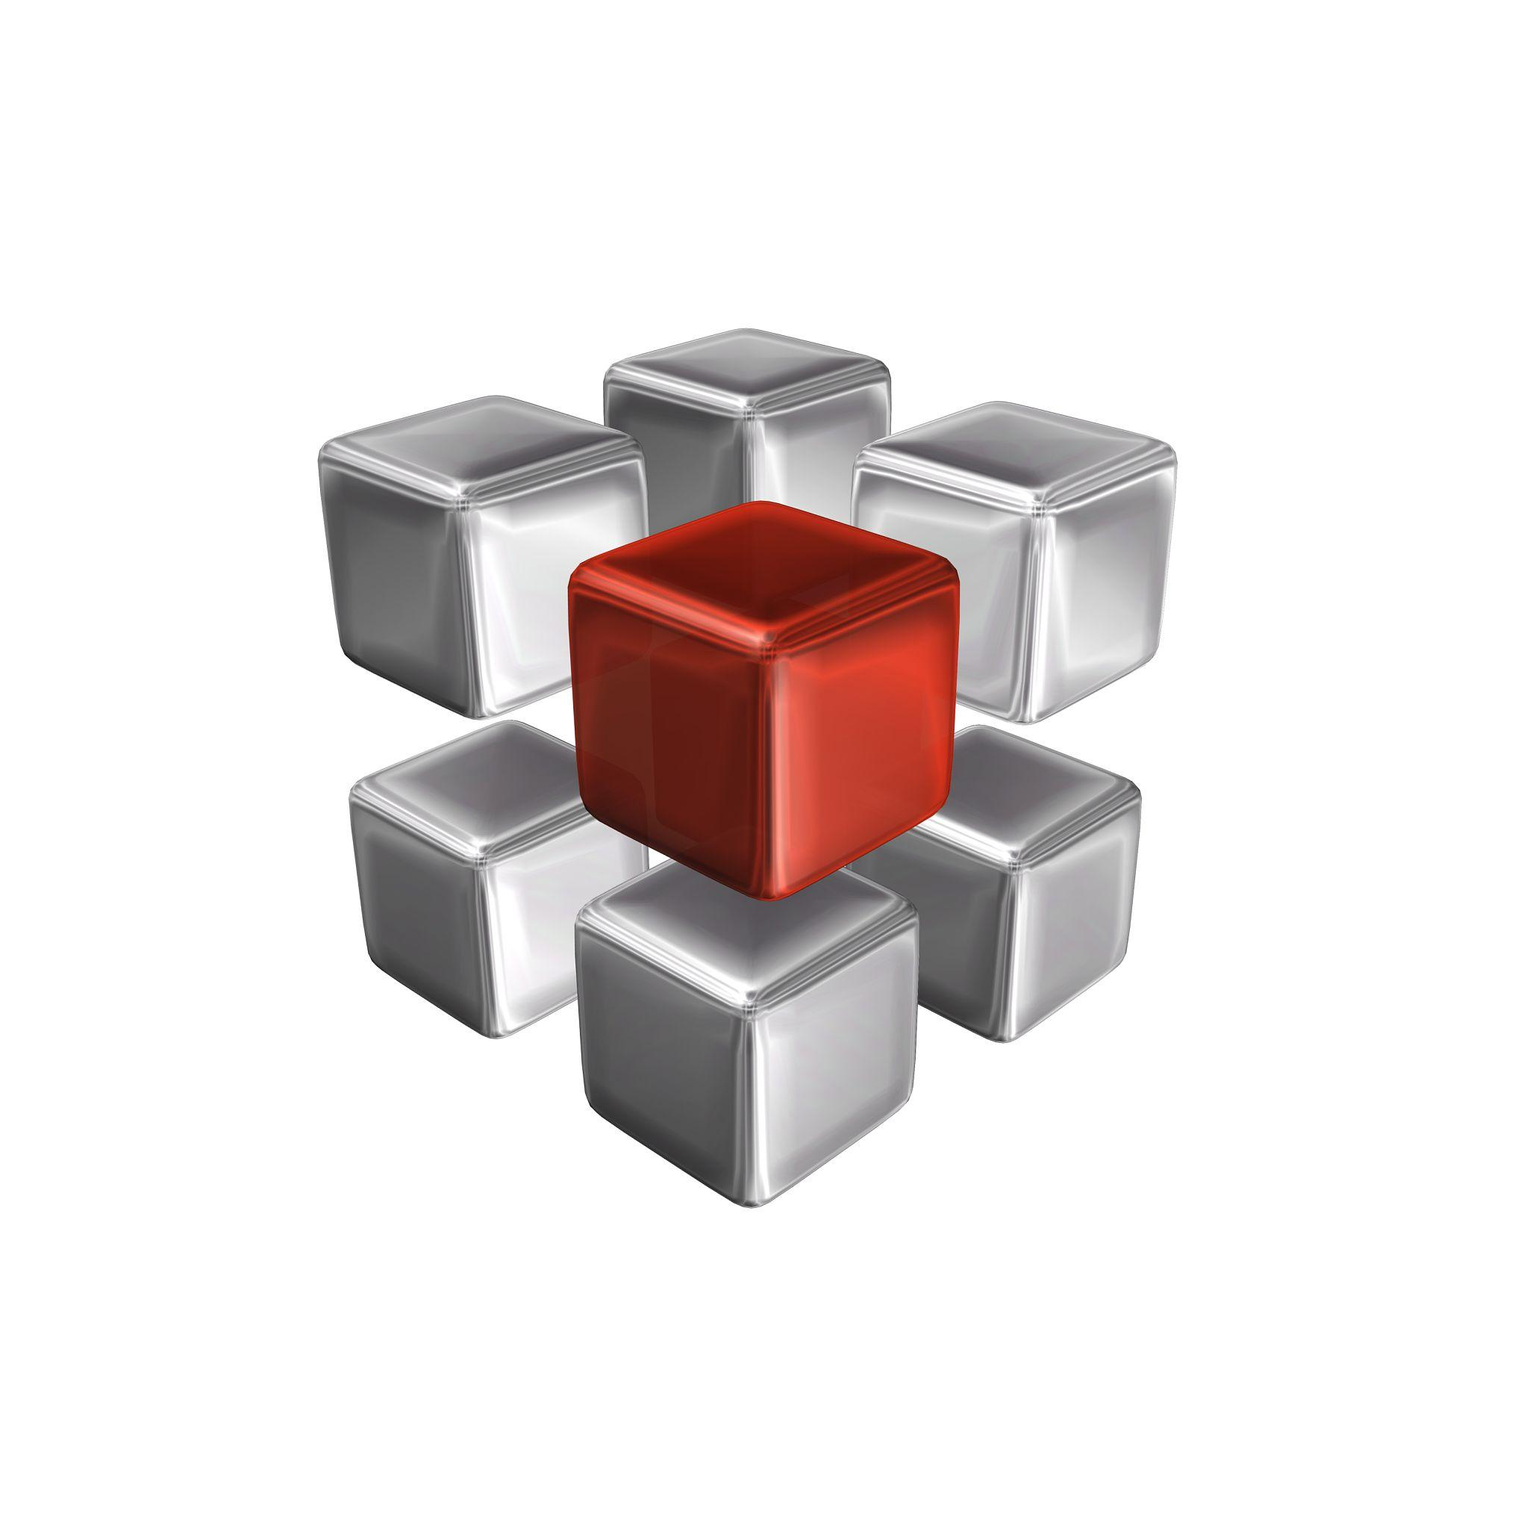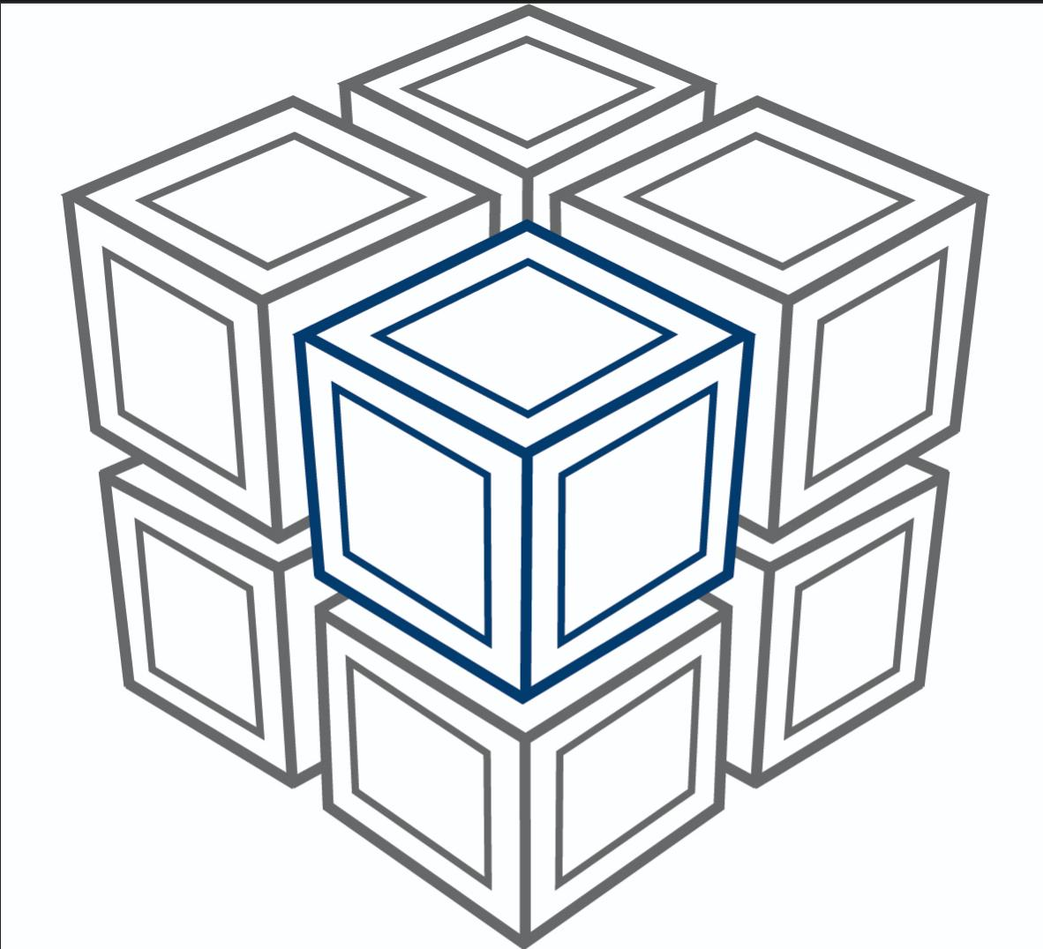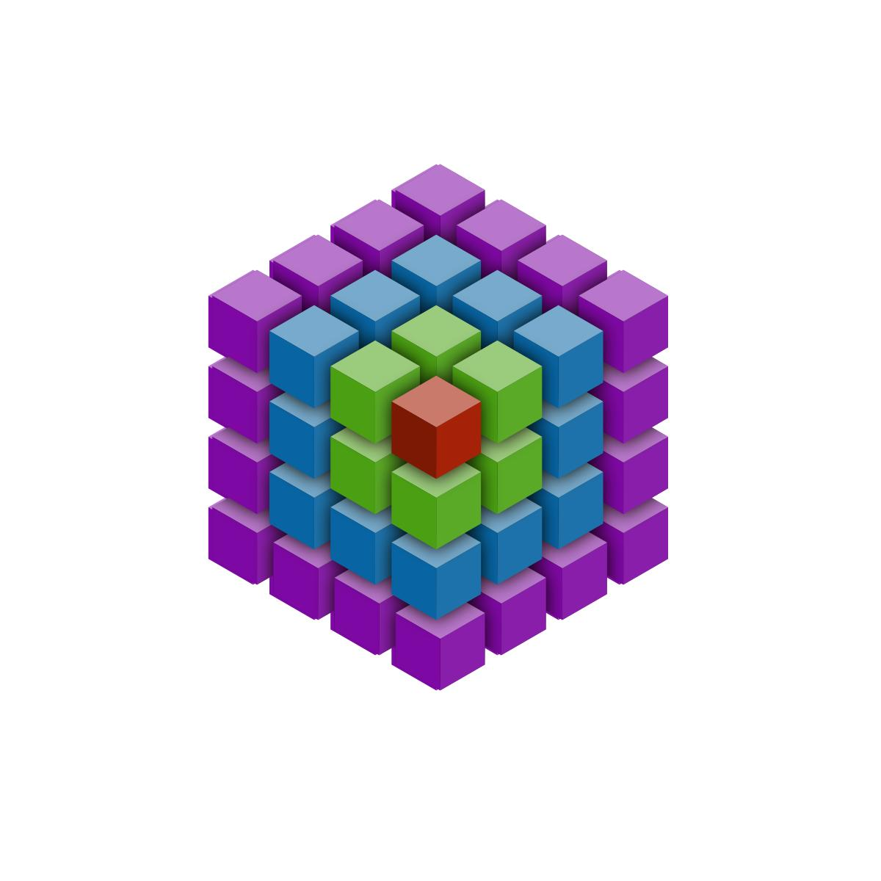
Main geometric elements:
- Center of Symmetry: A reference point around which corresponding components are positioned.
- Axis of Symmetry: A line around which the arrangement exhibits rotational symmetry.
- Plane of Symmetry: A plane that divides the arrangement into two matching reflected parts.
- Corresponding Components: Components that occupy matching positions under a symmetry transformation.
- Symmetry Transformation: A reflection, rotation, or other transformation that maps the arrangement onto itself.

Main Classification
# Source: AI Source: Provided by: [Data Path: Persons Table -> ID Column: 1, Name_En Column: Motasem Essam] -> From: [ChatGPT] on [7/25/2026]
Symmetrical arrangements can be classified according to the type of symmetry used to organize their components.

Classification by Type of Symmetry
# Source: AI Source: Provided by: [Data Path: Persons Table -> ID Column: 1, Name_En Column: Motasem Essam] -> From: [ChatGPT] on [7/25/2026]
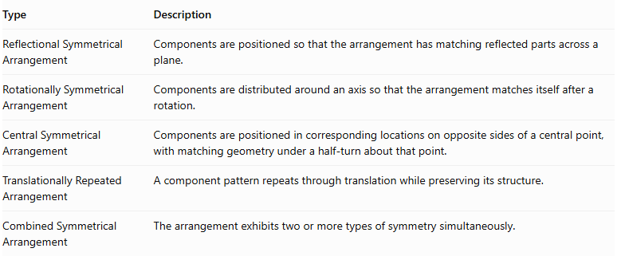
Type | Description
Reflectional Symmetrical Arrangement | Components are positioned so that the arrangement has matching reflected parts across a plane.
Rotationally Symmetrical Arrangement | Components are distributed around an axis so that the arrangement matches itself after a rotation.
Central Symmetrical Arrangement | Components are positioned in corresponding locations on opposite sides of a central point, with matching geometry under a half-turn about that point.
Translationally Repeated Arrangement | A component pattern repeats through translation while preserving its structure.
Combined Symmetrical Arrangement | The arrangement exhibits two or more types of symmetry simultaneously.
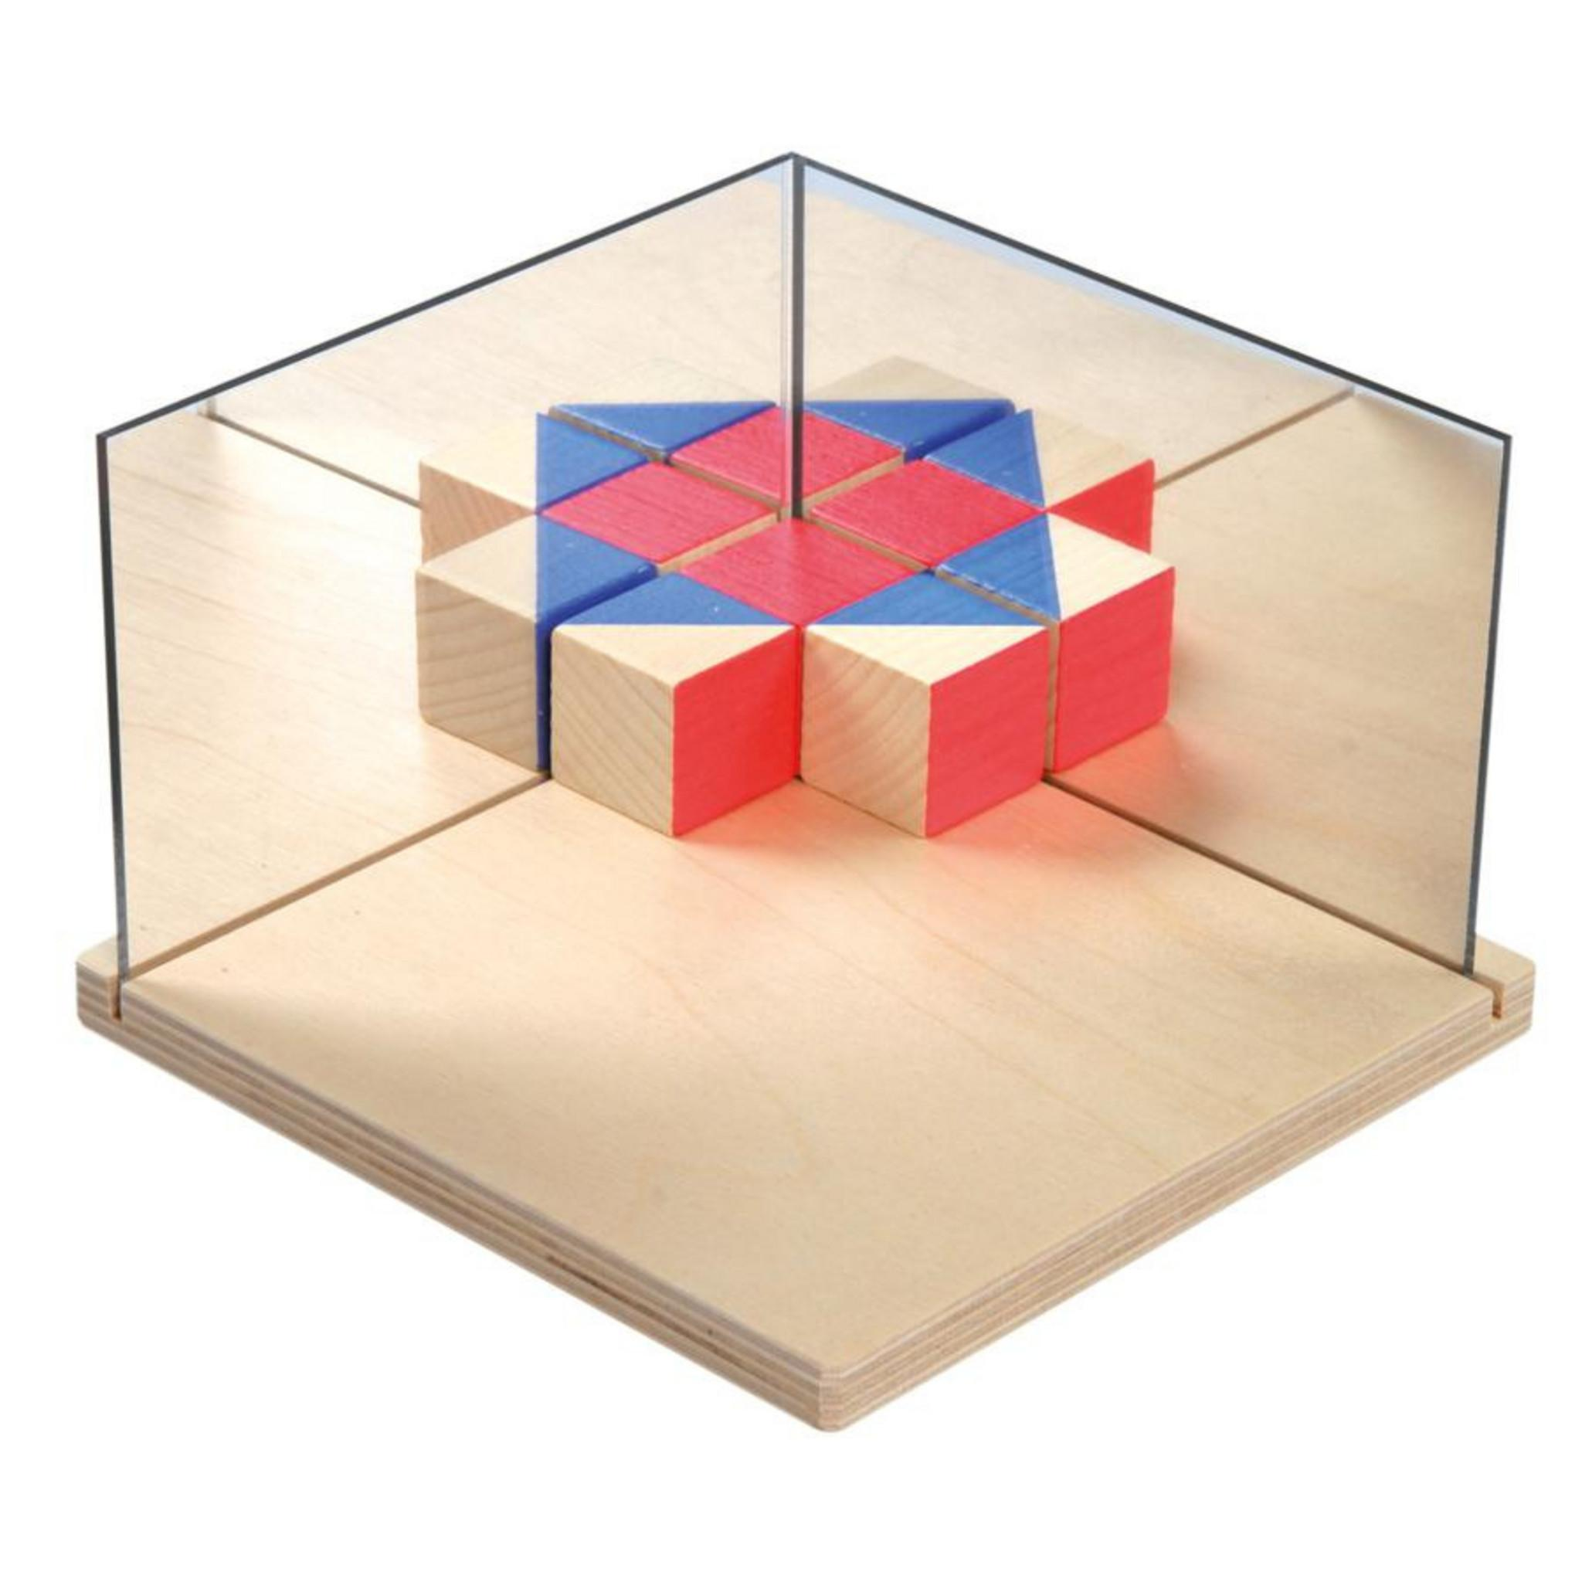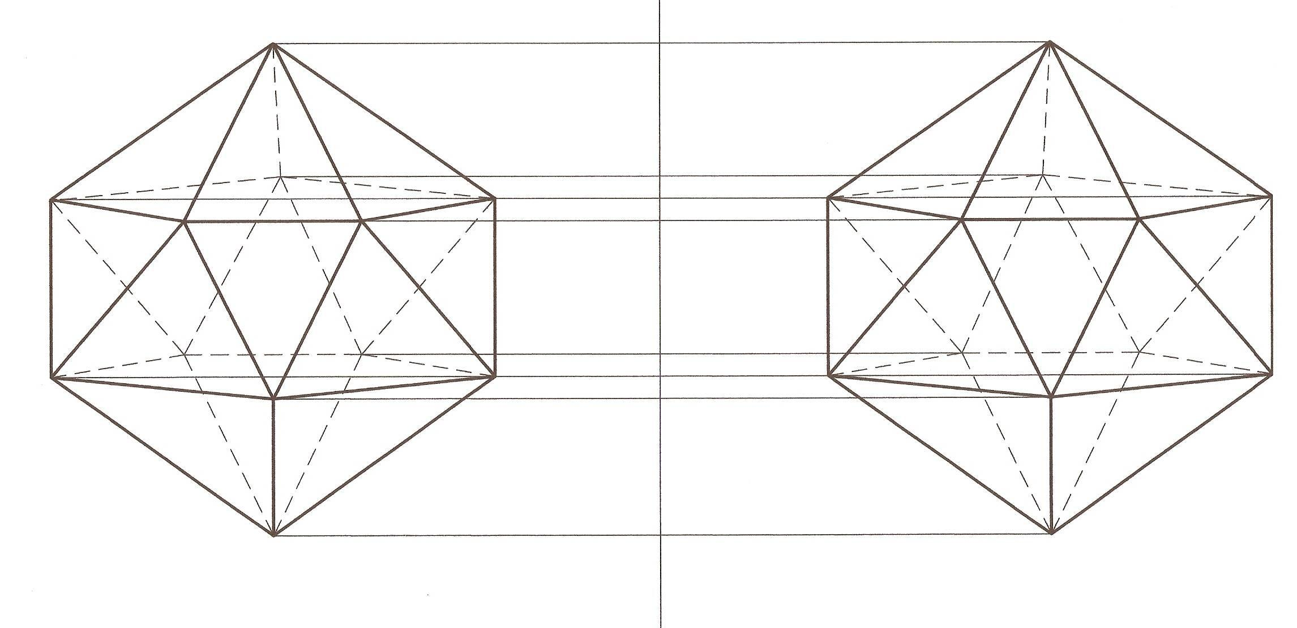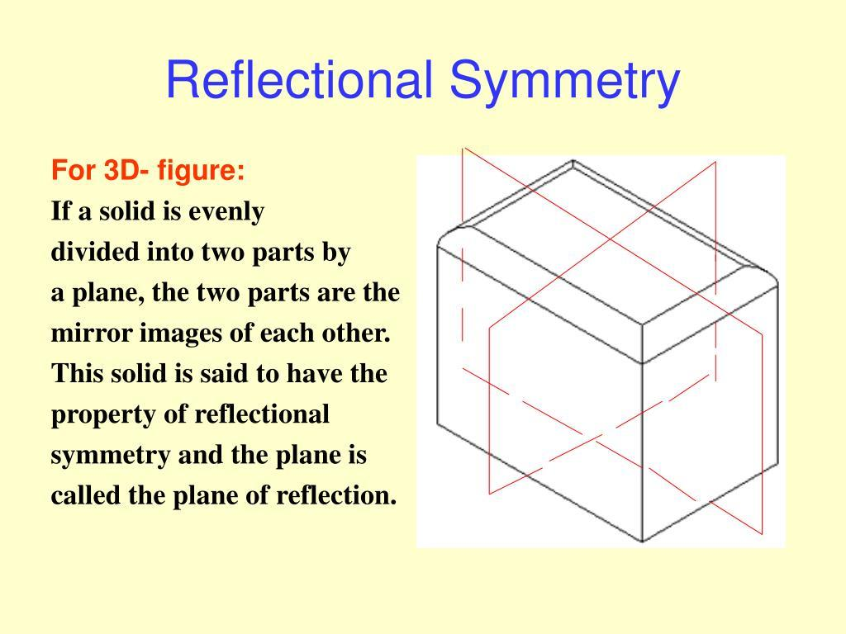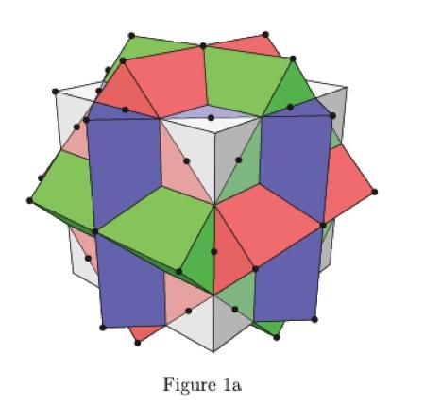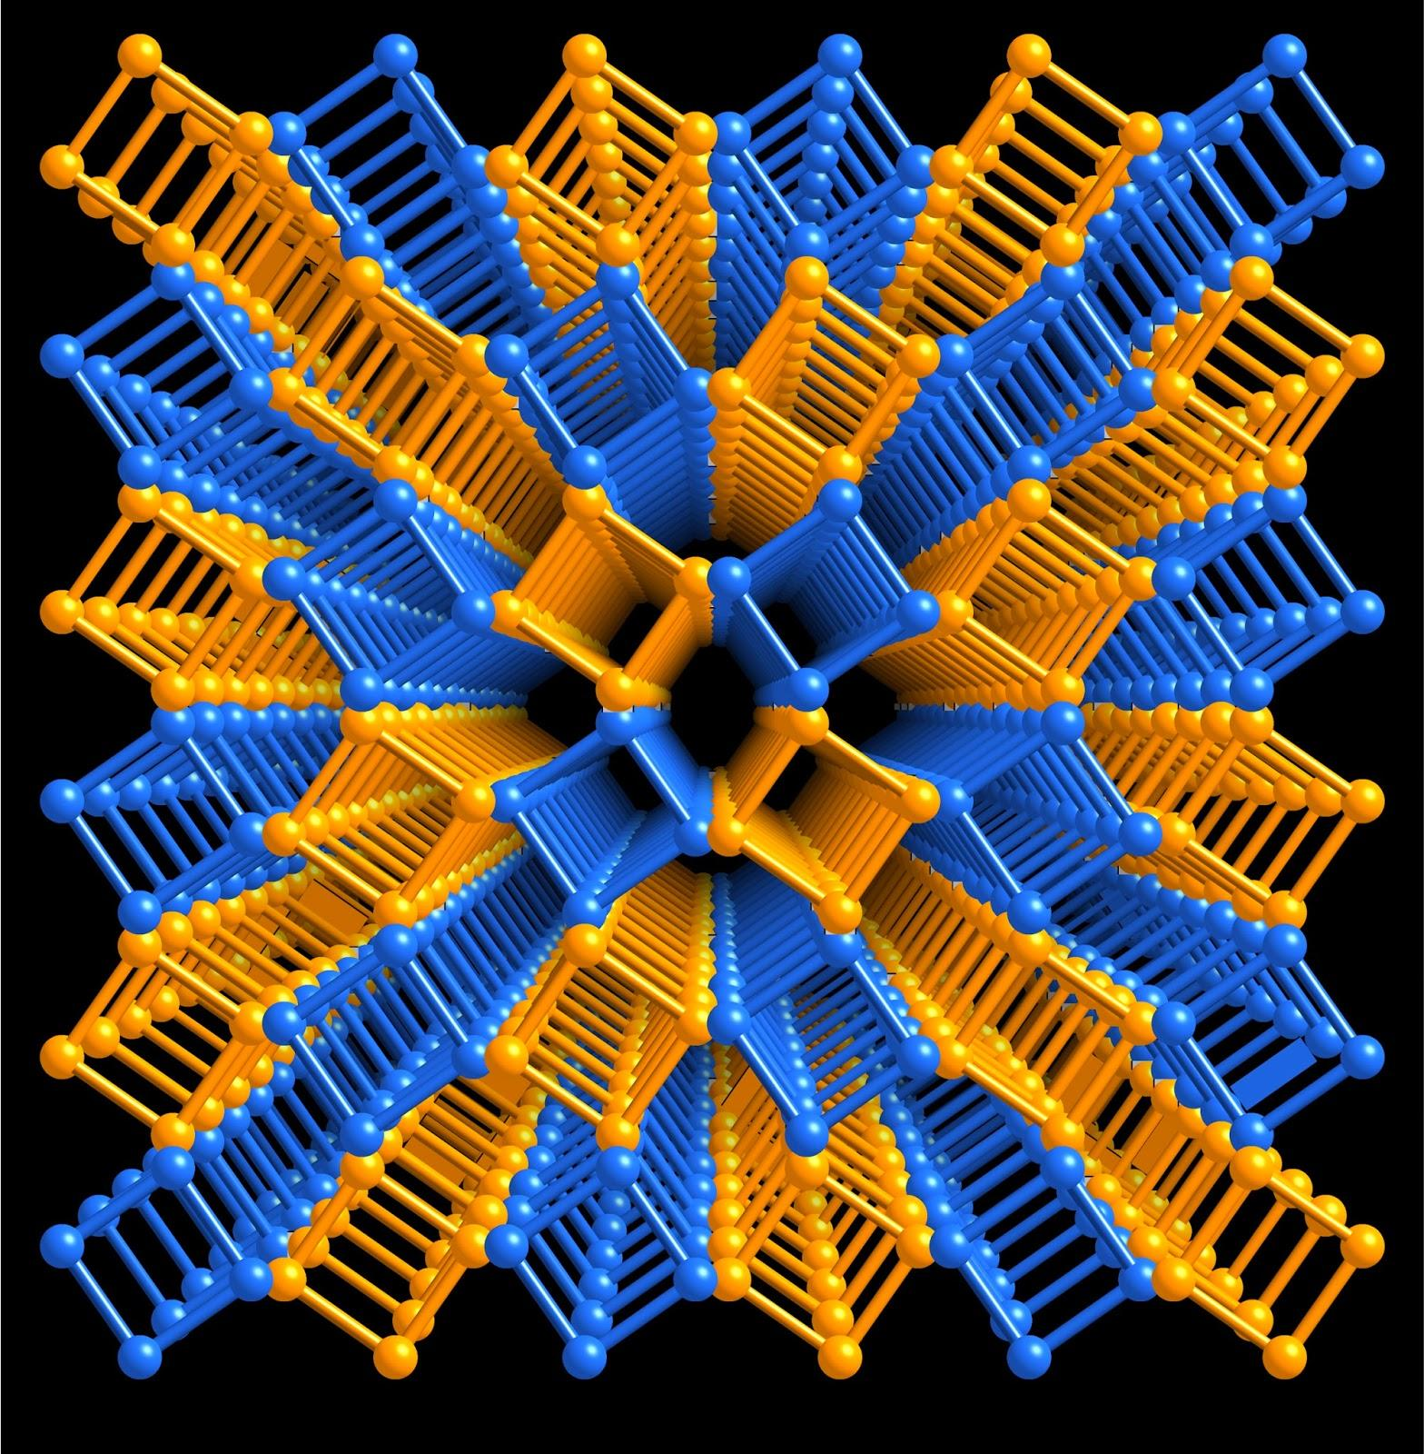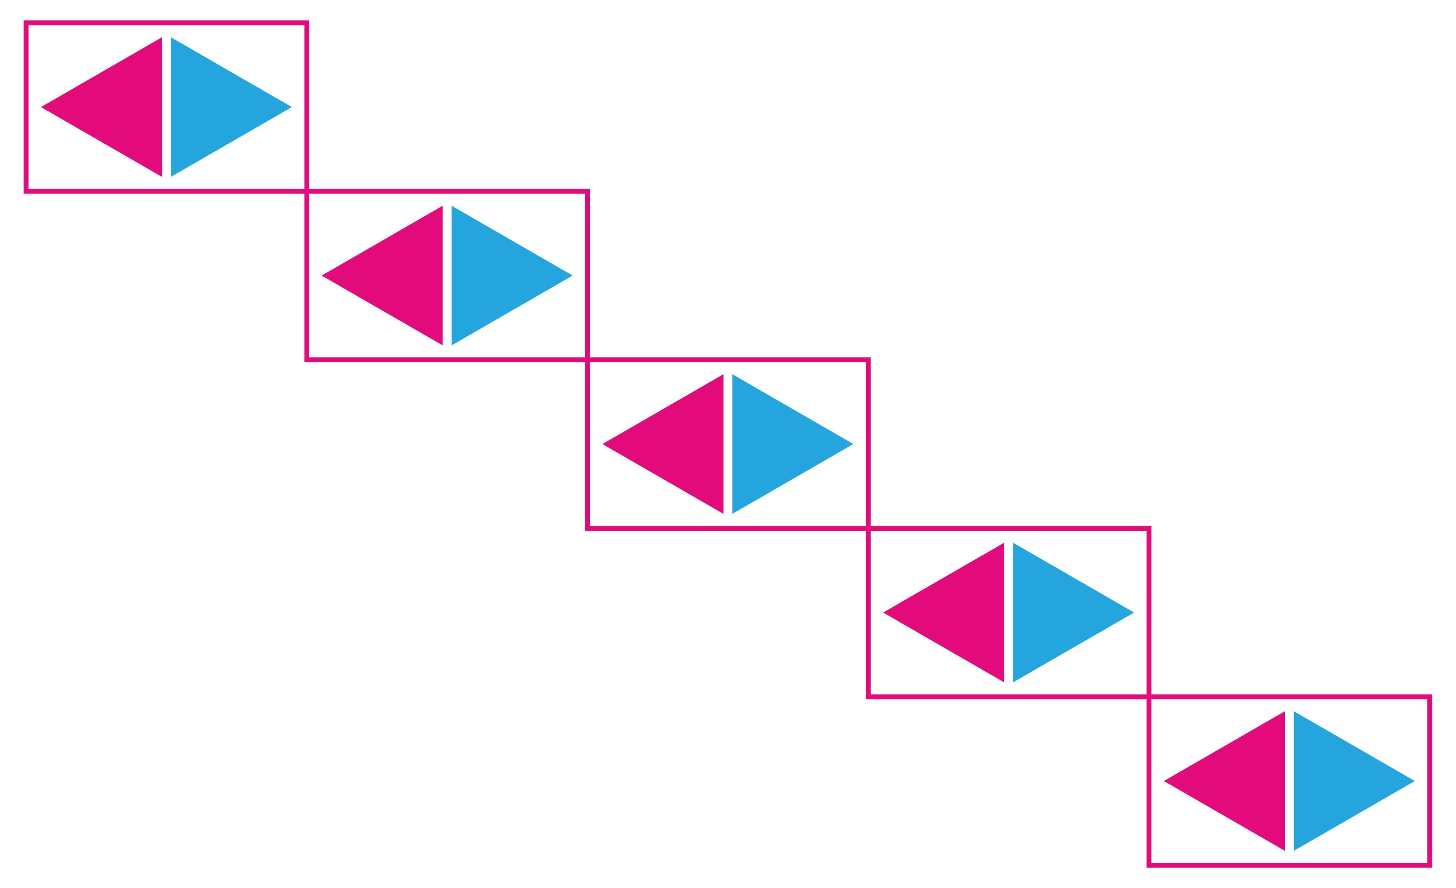

Classification by Plane of Symmetry
# Source: AI Source: Provided by: [Data Path: Persons Table -> ID Column: 1, Name_En Column: Motasem Essam] -> From: [ChatGPT] on [7/25/2026]
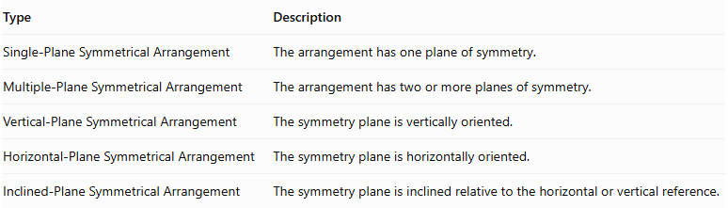
Type | Description
Single-Plane Symmetrical Arrangement | The arrangement has one plane of symmetry.
Multiple-Plane Symmetrical Arrangement | The arrangement has two or more planes of symmetry.
Vertical-Plane Symmetrical Arrangement | The symmetry plane is vertically oriented.
Horizontal-Plane Symmetrical Arrangement | The symmetry plane is horizontally oriented.
Inclined-Plane Symmetrical Arrangement | The symmetry plane is inclined relative to the horizontal or vertical reference.
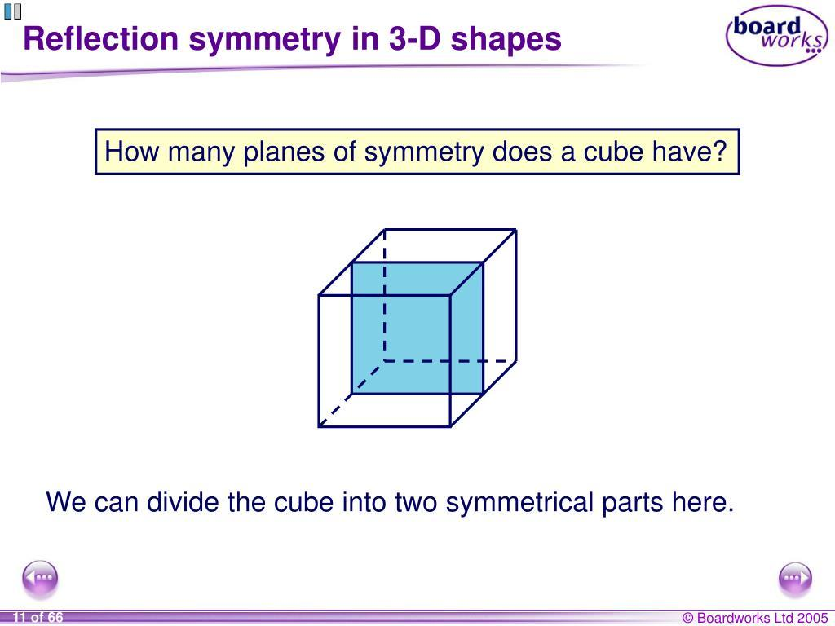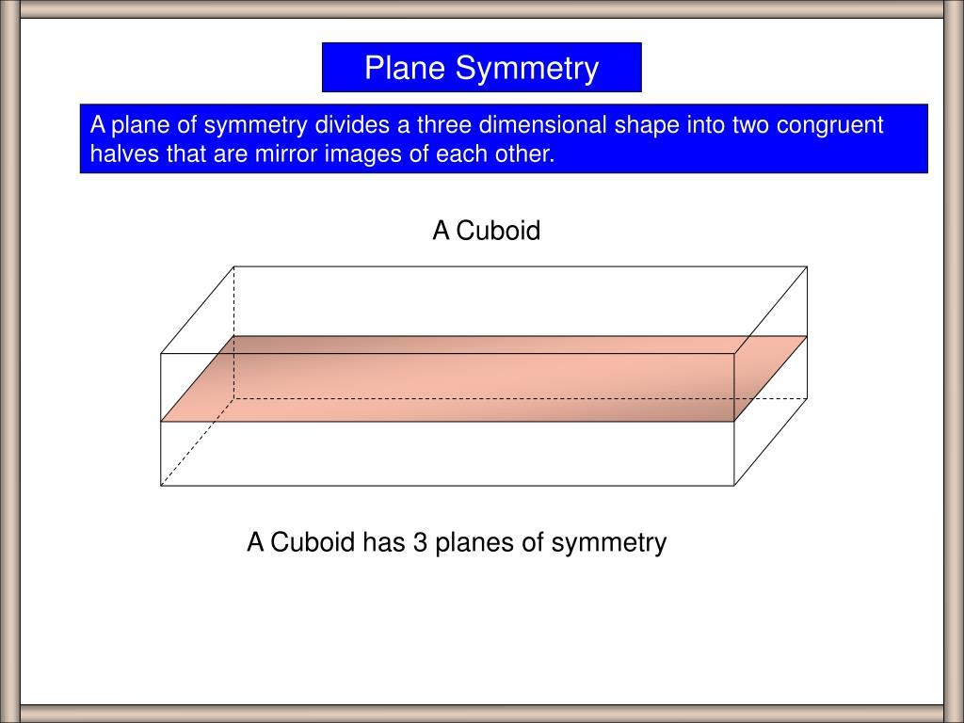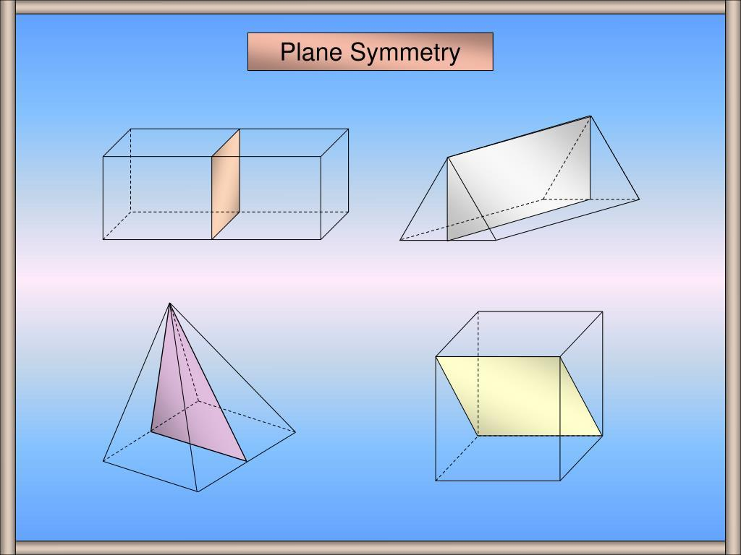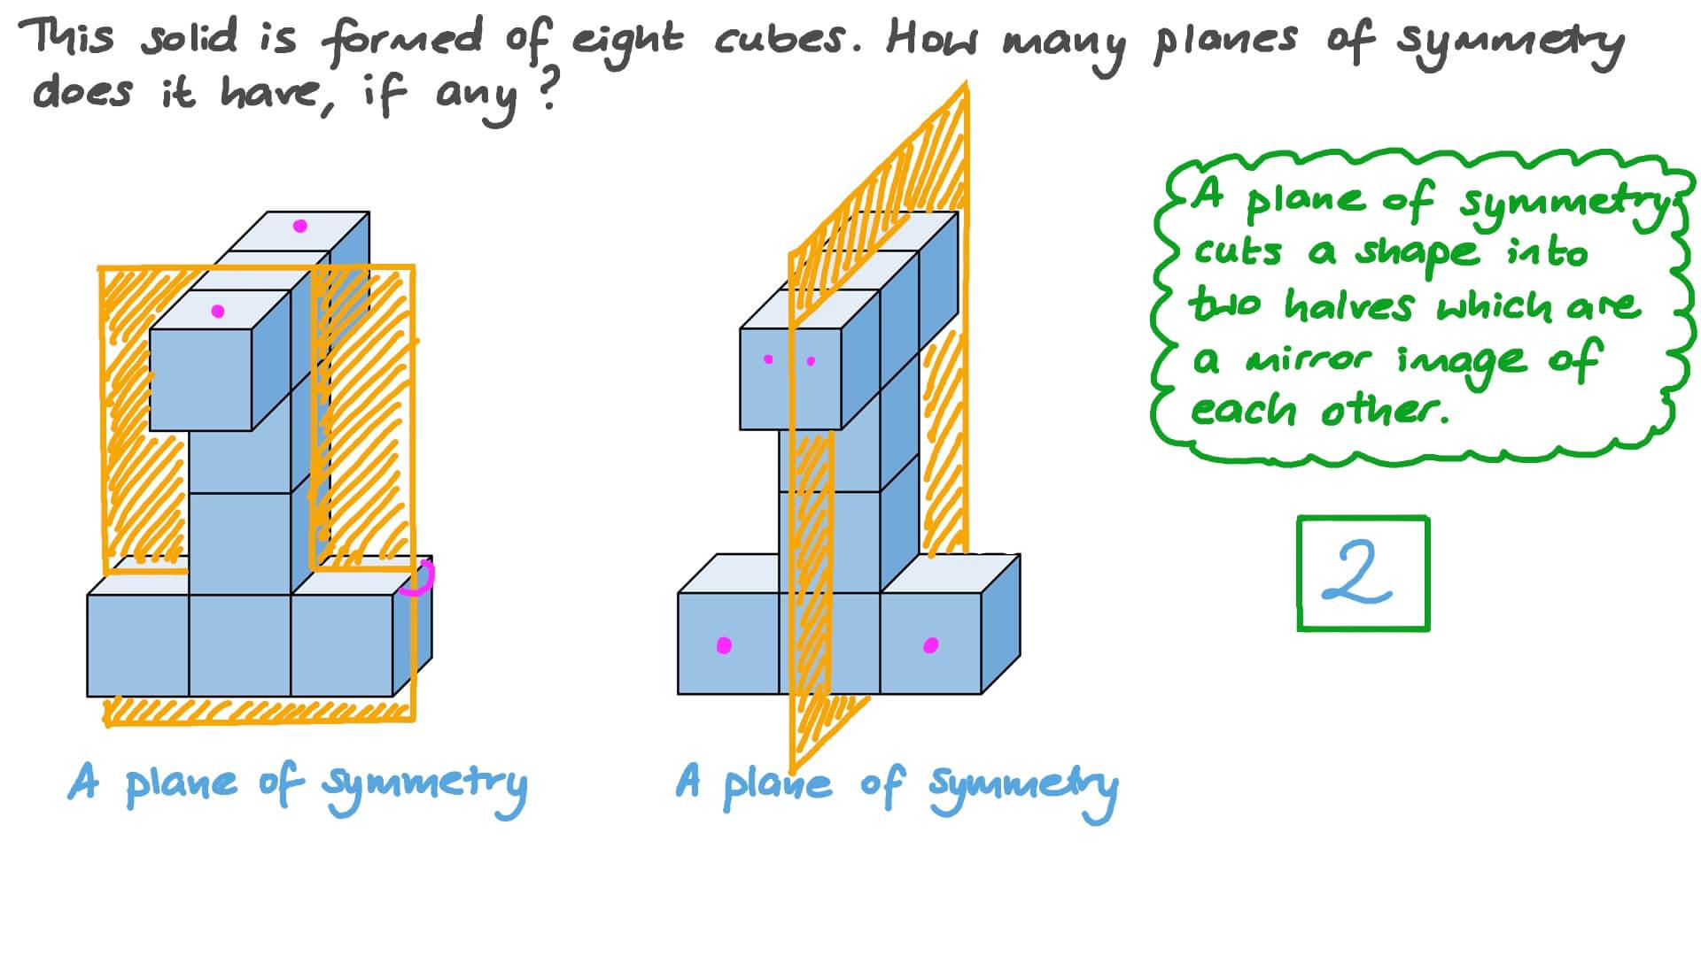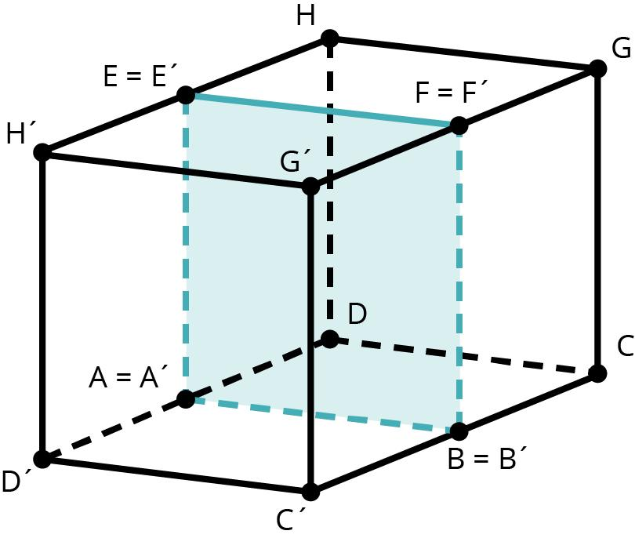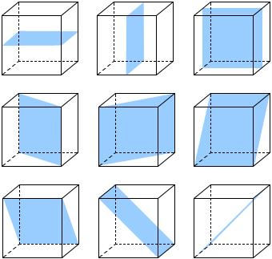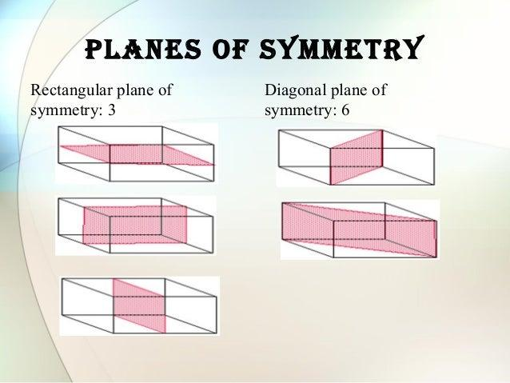

Classification by Component Distribution
# Source: AI Source: Provided by: [Data Path: Persons Table -> ID Column: 1, Name_En Column: Motasem Essam] -> From: [ChatGPT] on [7/25/2026]
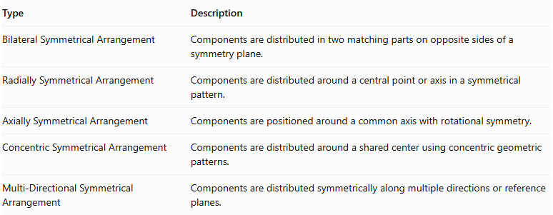
Type | Description
Bilateral Symmetrical Arrangement | Components are distributed in two matching parts on opposite sides of a symmetry plane.
Radially Symmetrical Arrangement | Components are distributed around a central point or axis in a symmetrical pattern.
Axially Symmetrical Arrangement | Components are positioned around a common axis with rotational symmetry.
Concentric Symmetrical Arrangement | Components are distributed around a shared center using concentric geometric patterns.
Multi-Directional Symmetrical Arrangement | Components are distributed symmetrically along multiple directions or reference planes.
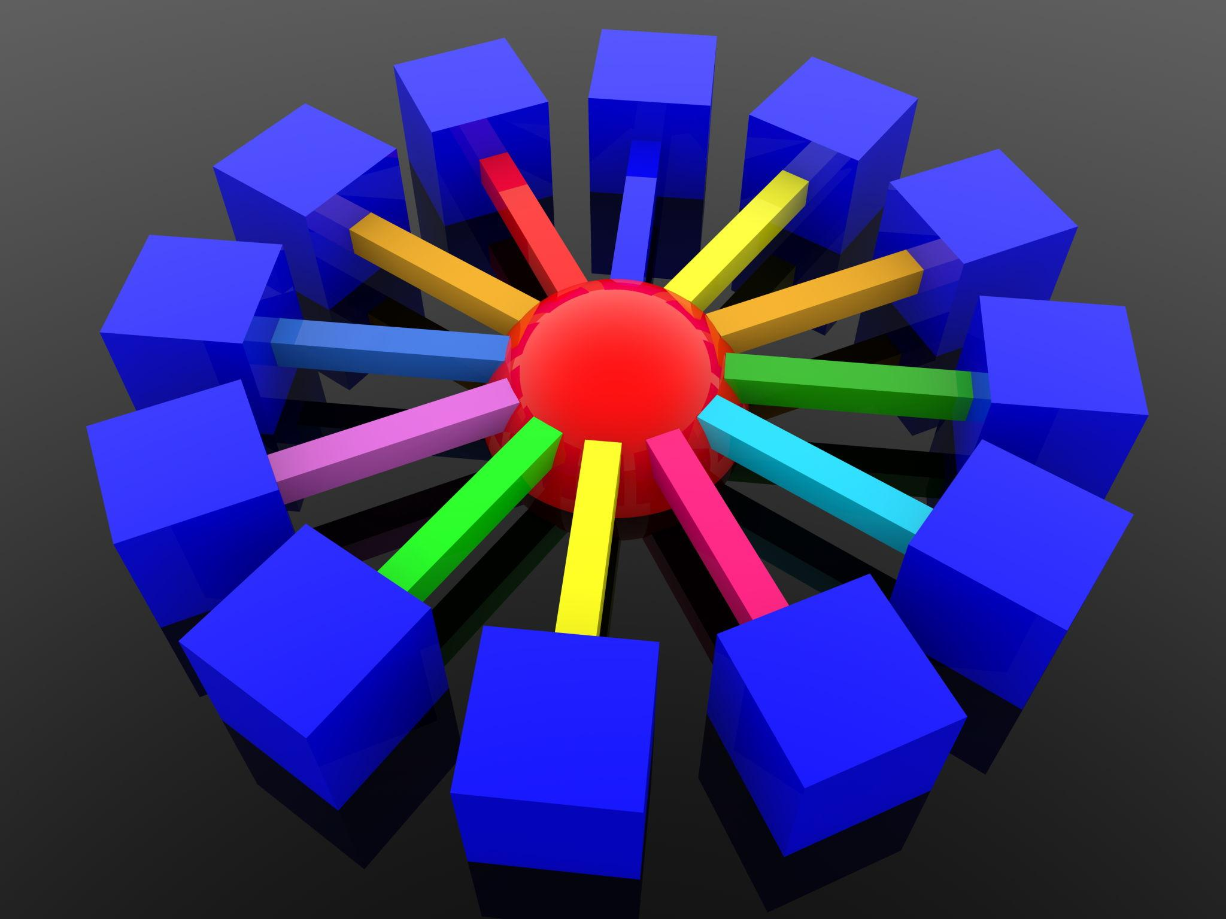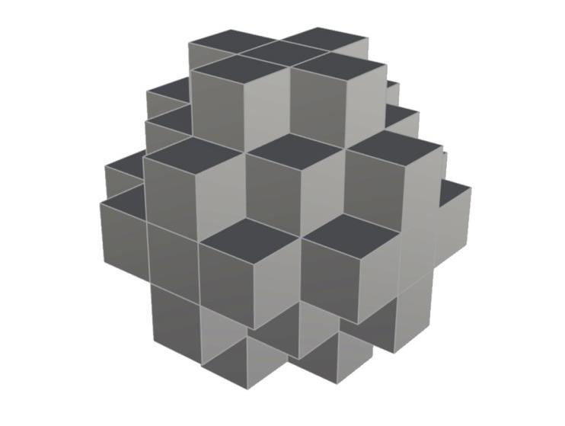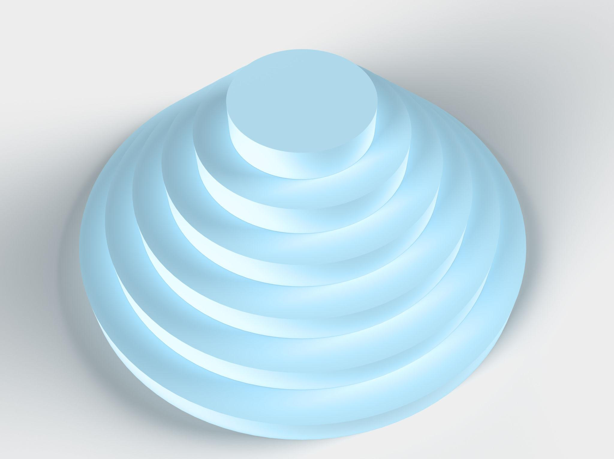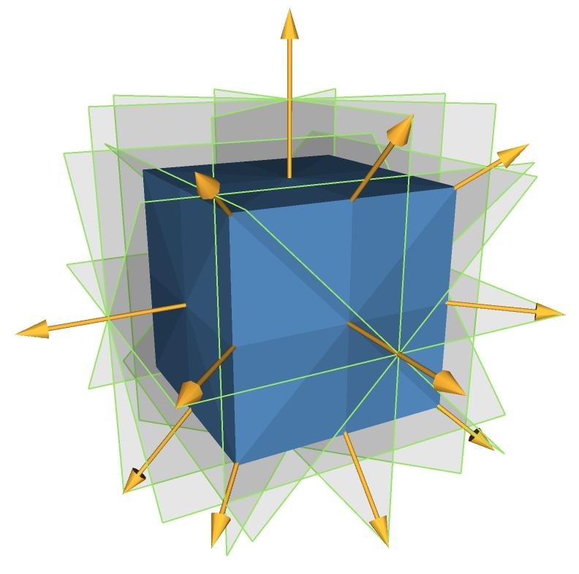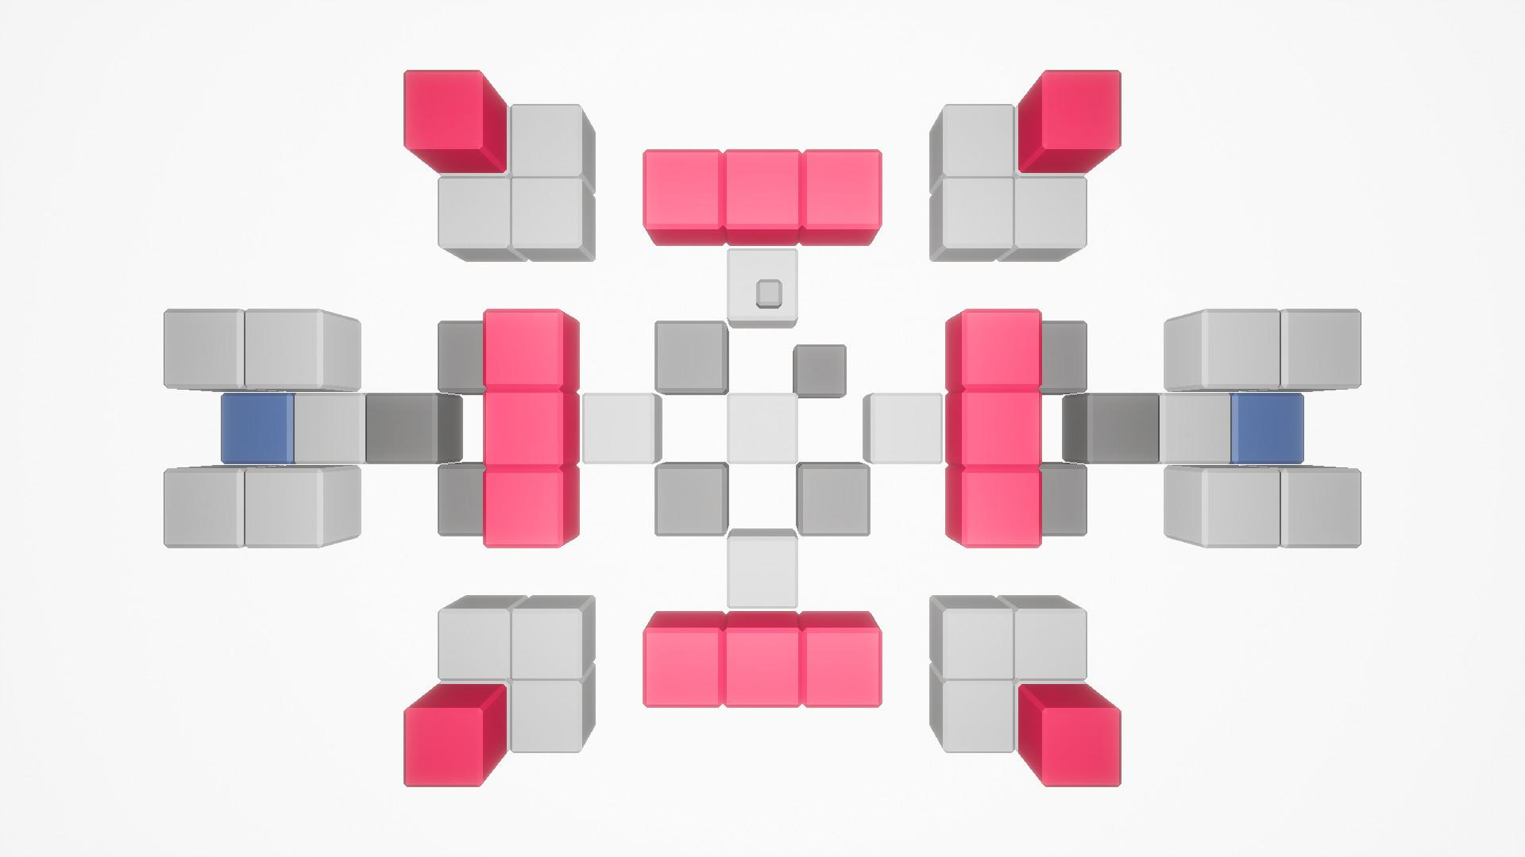

Classification by Component Dimensions
# Source: AI Source: Provided by: [Data Path: Persons Table -> ID Column: 1, Name_En Column: Motasem Essam] -> From: [ChatGPT] on [7/25/2026]
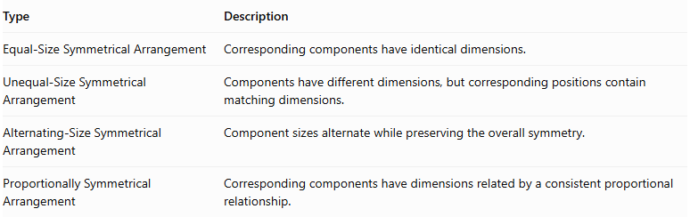
Type | Description
Equal-Size Symmetrical Arrangement | Corresponding components have identical dimensions.
Unequal-Size Symmetrical Arrangement | Components have different dimensions, but corresponding positions contain matching dimensions.
Alternating-Size Symmetrical Arrangement | Component sizes alternate while preserving the overall symmetry.
Proportionally Symmetrical Arrangement | Corresponding components have dimensions related by a consistent proportional relationship.
Important: Symmetry does not always require every component to have the same dimensions. It requires corresponding components to match under the relevant symmetry transformation.
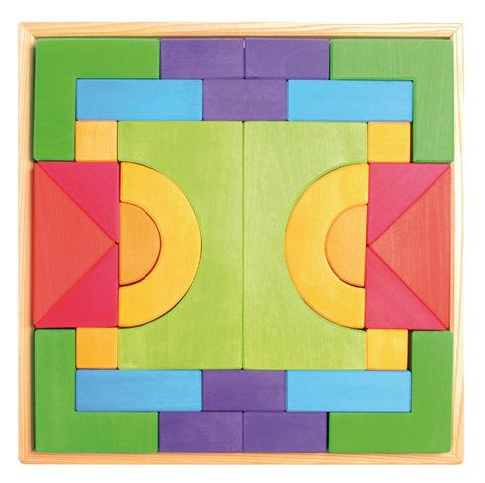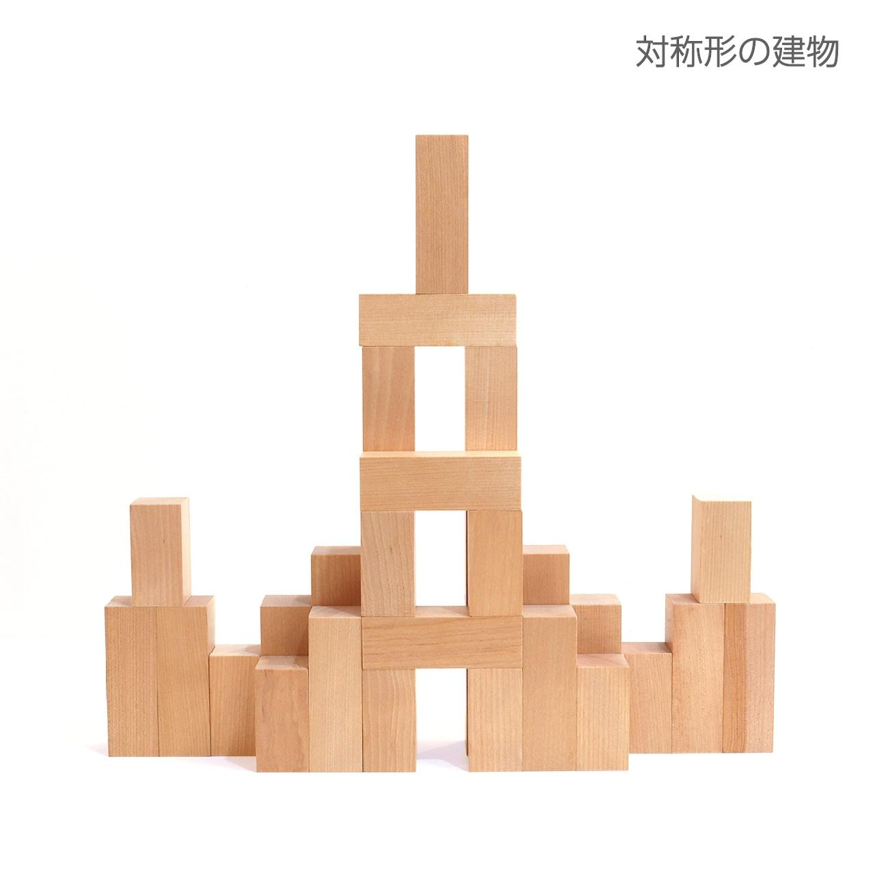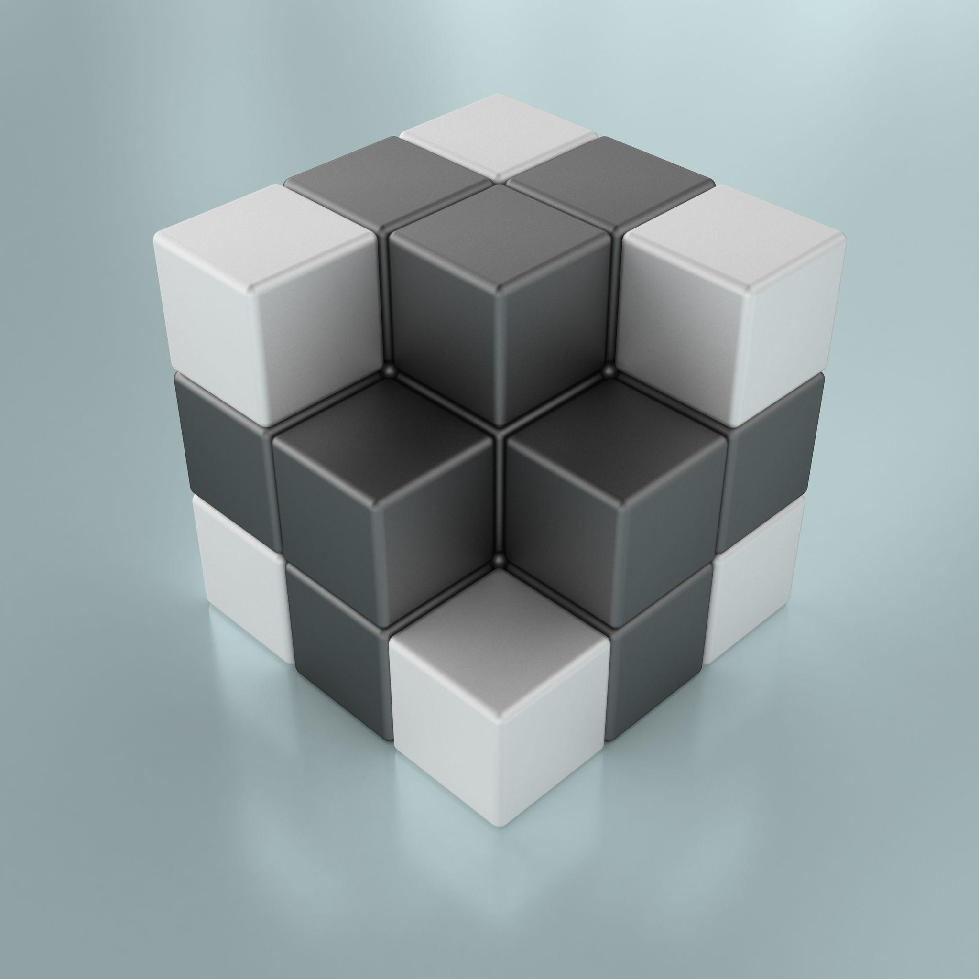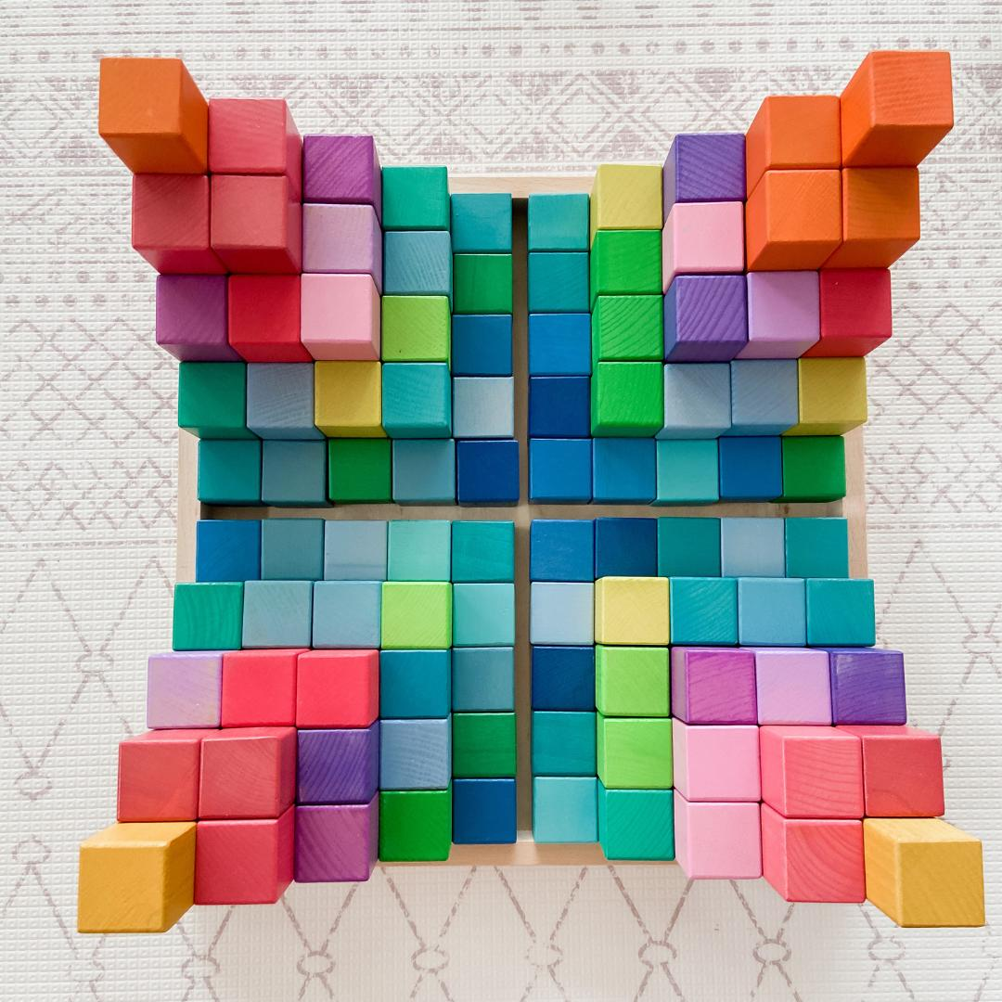

Classification by Component Shape
# Source: AI Source: Provided by: [Data Path: Persons Table -> ID Column: 1, Name_En Column: Motasem Essam] -> From: [ChatGPT] on [7/25/2026]
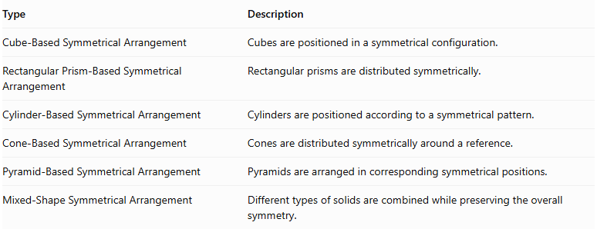
Type | Description
Cube-Based Symmetrical Arrangement | Cubes are positioned in a symmetrical configuration.
Rectangular Prism-Based Symmetrical Arrangement | Rectangular prisms are distributed symmetrically.
Cylinder-Based Symmetrical Arrangement | Cylinders are positioned according to a symmetrical pattern.
Cone-Based Symmetrical Arrangement | Cones are distributed symmetrically around a reference.
Pyramid-Based Symmetrical Arrangement | Pyramids are arranged in corresponding symmetrical positions.
Mixed-Shape Symmetrical Arrangement | Different types of solids are combined while preserving the overall symmetry.
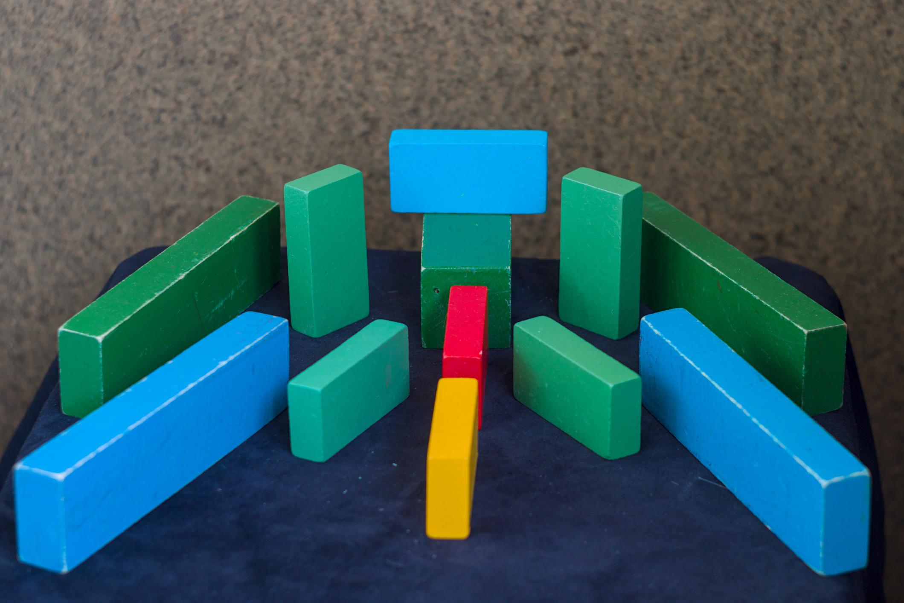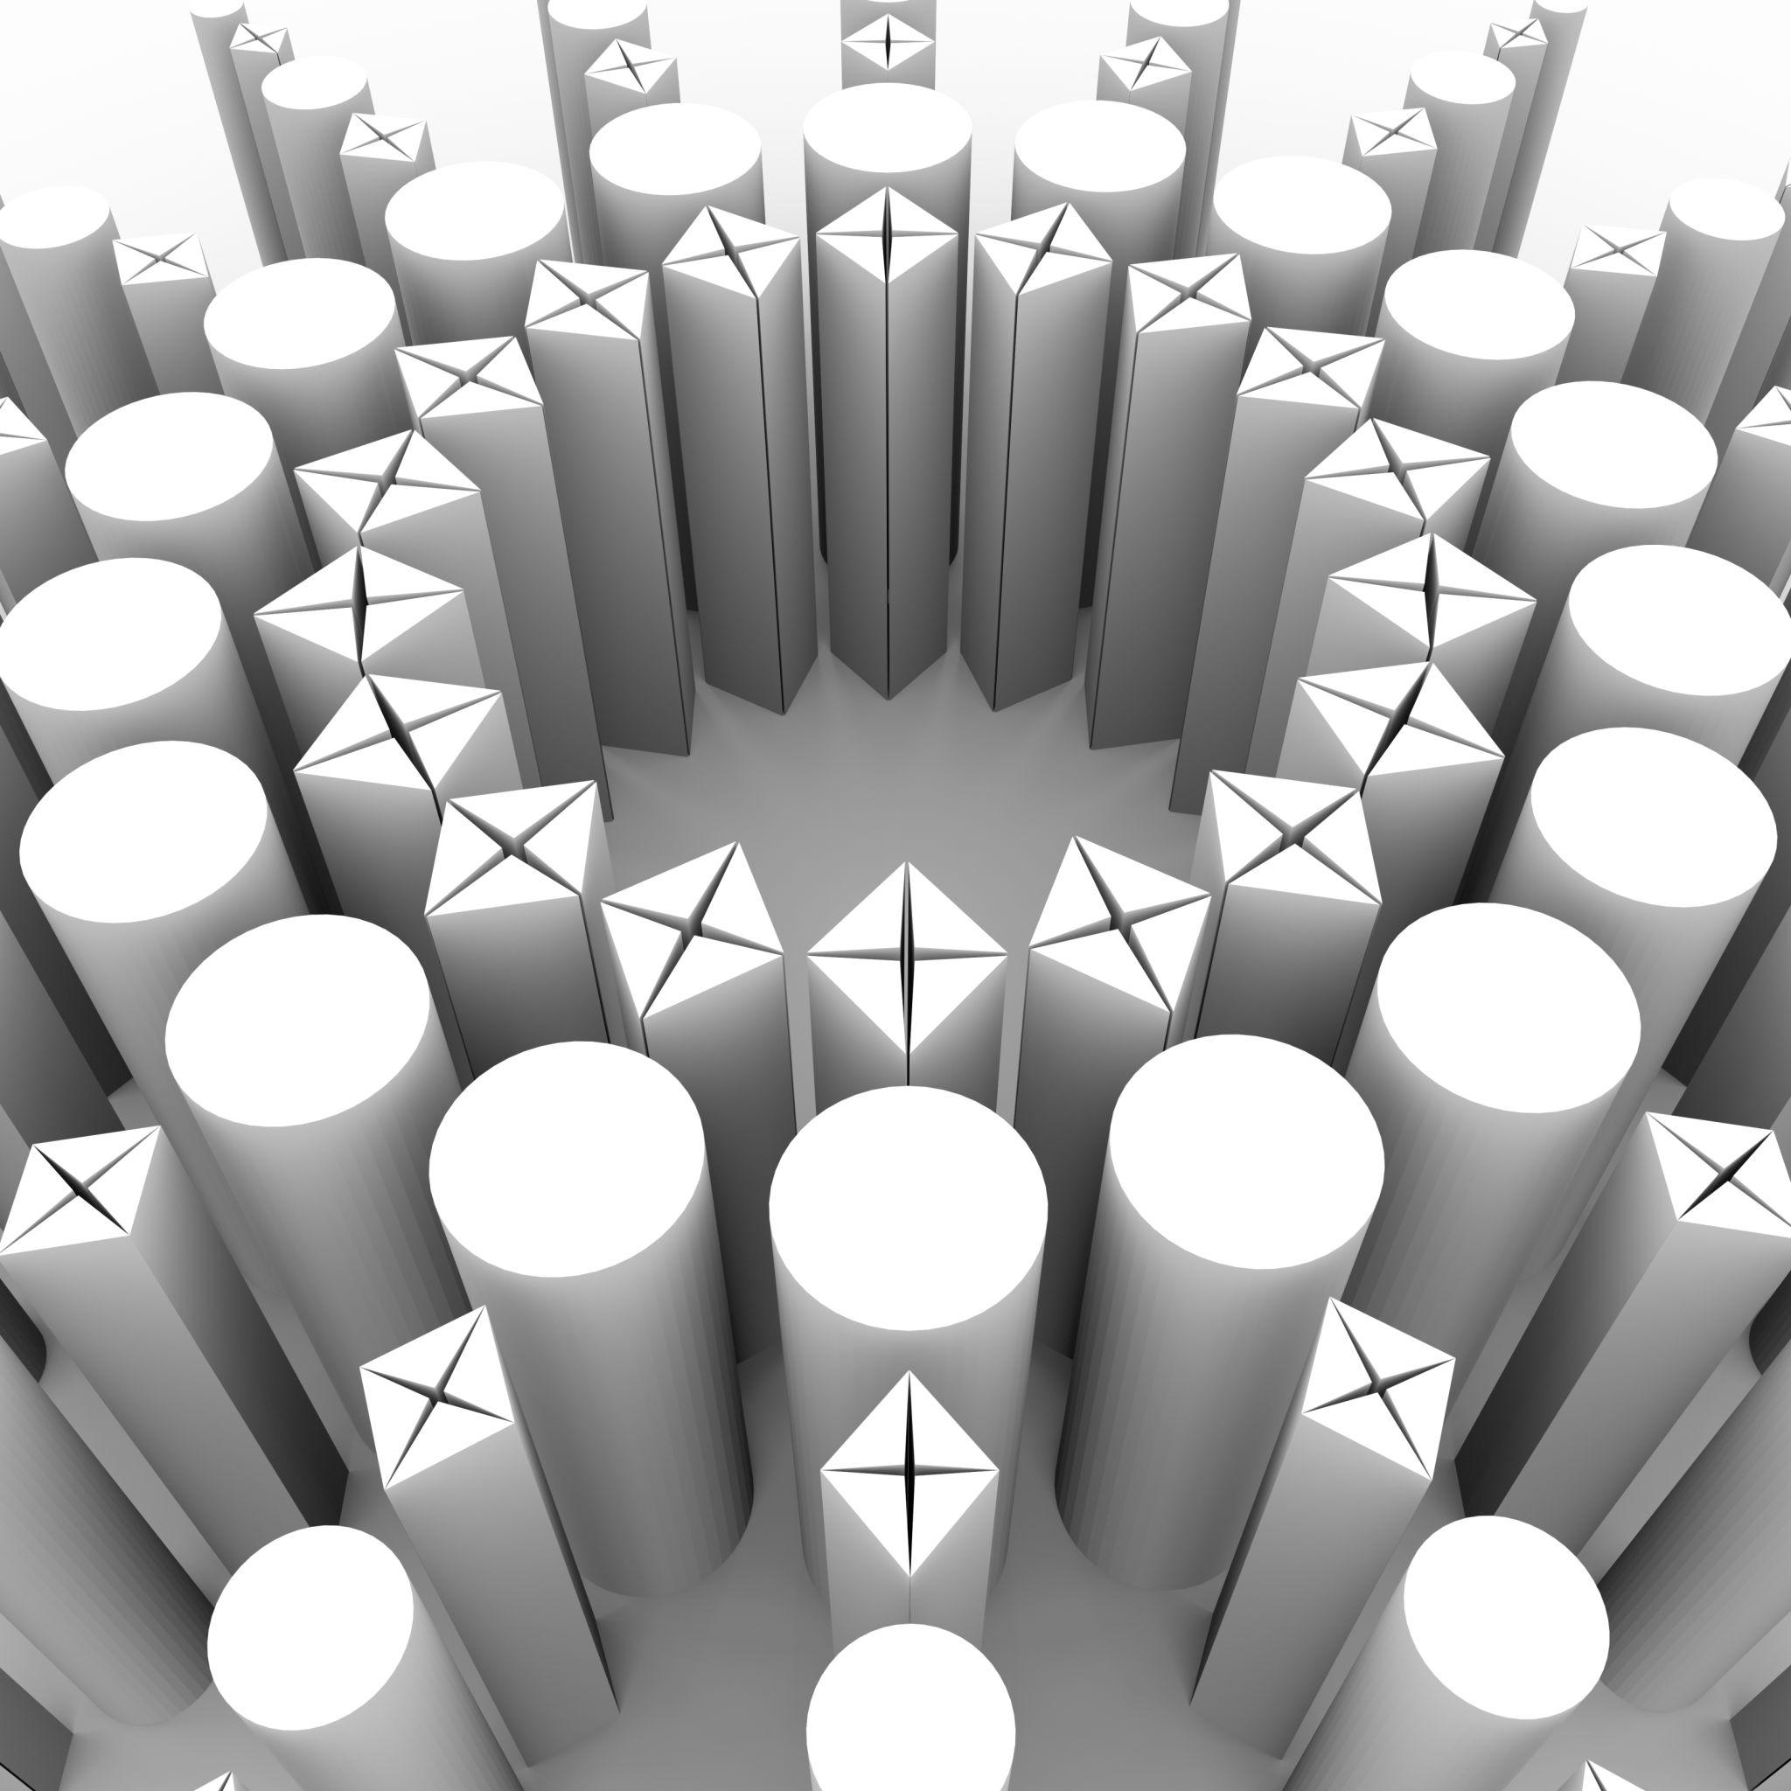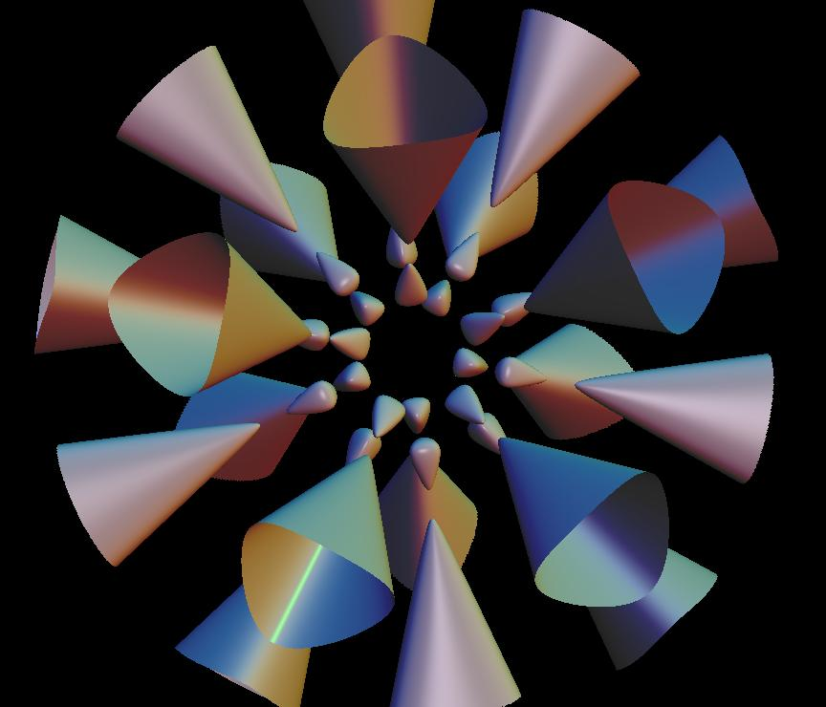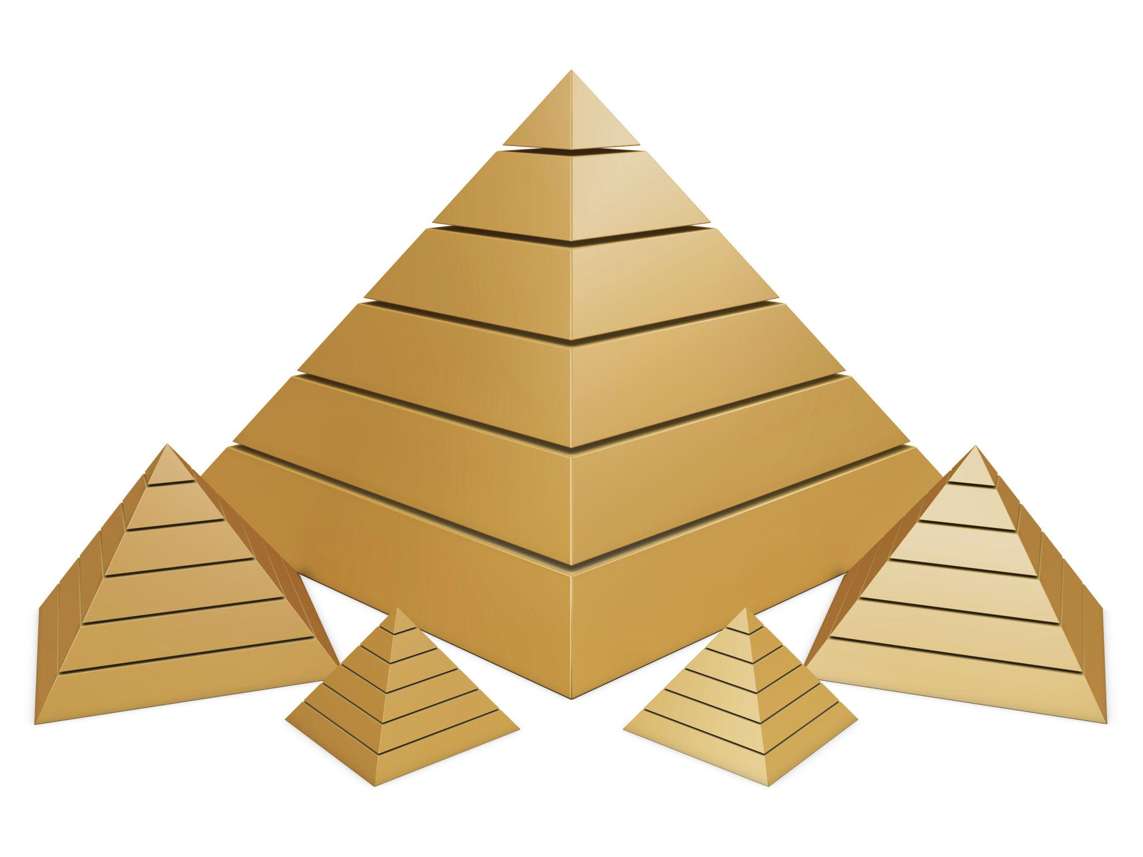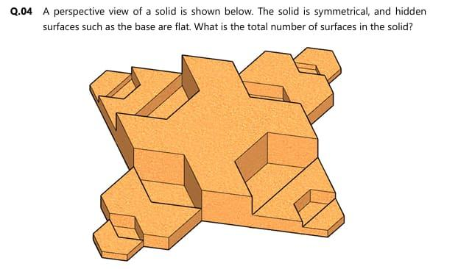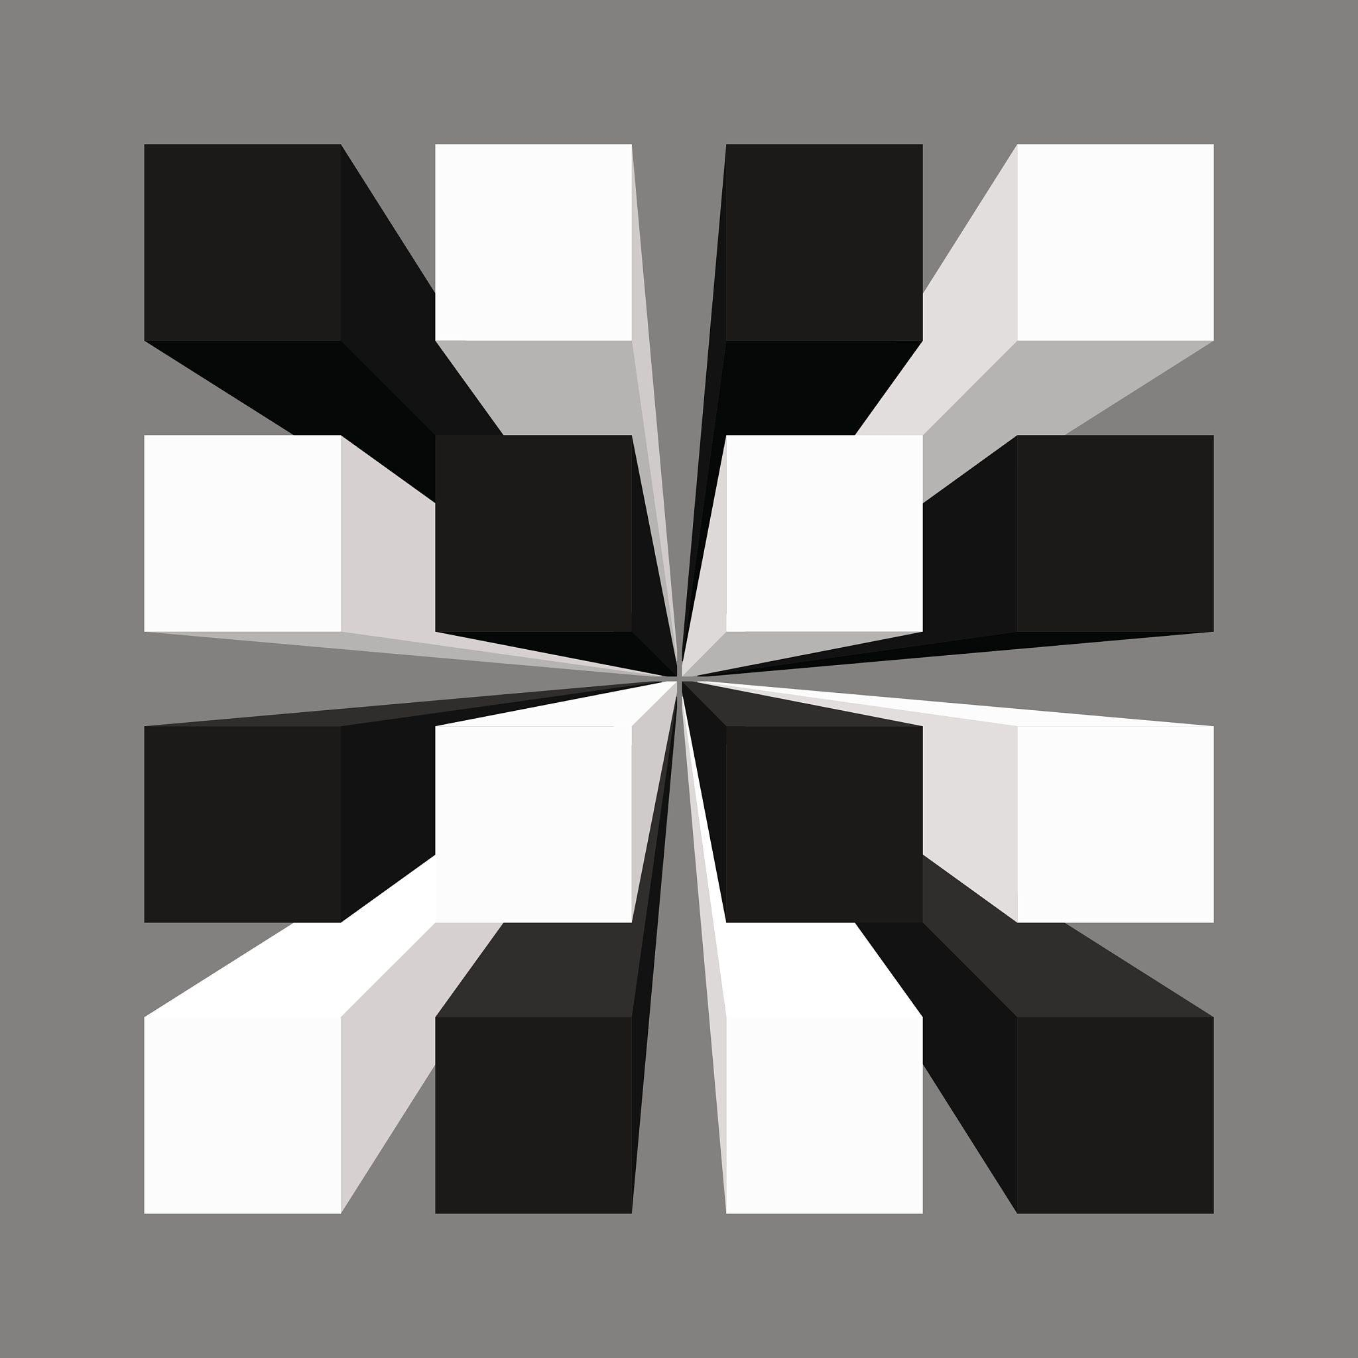

Classification by Component Orientation
# Source: AI Source: Provided by: [Data Path: Persons Table -> ID Column: 1, Name_En Column: Motasem Essam] -> From: [ChatGPT] on [7/25/2026]
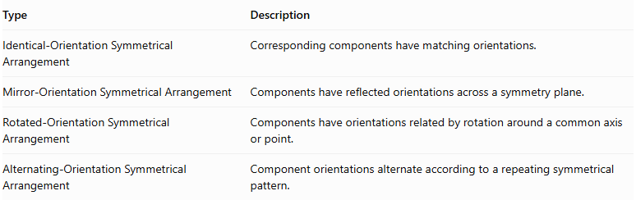
Type | Description
Identical-Orientation Symmetrical Arrangement | Corresponding components have matching orientations.
Mirror-Orientation Symmetrical Arrangement | Components have reflected orientations across a symmetry plane.
Rotated-Orientation Symmetrical Arrangement | Components have orientations related by rotation around a common axis or point.
Alternating-Orientation Symmetrical Arrangement | Component orientations alternate according to a repeating symmetrical pattern.

Mathematical Properties and Formulas

Reflectional Symmetry
# Source: AI Source: Provided by: [Data Path: Persons Table -> ID Column: 1, Name_En Column: Motasem Essam] -> From: [ChatGPT] on [7/25/2026]
For reflection across the vertical plane $x=0$, a point transforms as:
$$(x,y,z)longrightarrow(-x,y,z)$$
For reflection across the horizontal plane $z=0$:
$$(x,y,z)longrightarrow(x,y,-z)$$
Corresponding components must occupy reflected positions and have matching geometry.

Rotational Symmetry
# Source: AI Source: Provided by: [Data Path: Persons Table -> ID Column: 1, Name_En Column: Motasem Essam] -> From: [ChatGPT] on [7/25/2026]
For $N$ equally spaced components around a complete circular axis:
$$\boxed{θ=\frac{{360}^{∘}}{N}}$$
Where:
- $θ$ = Angular separation.
- $N$ = Number of repeated components.
For example, six equally spaced components have:
$$θ=\frac{{360}^{∘}}{6}={60}^{∘}$$

Central Symmetry
# Source: AI Source: Provided by: [Data Path: Persons Table -> ID Column: 1, Name_En Column: Motasem Essam] -> From: [ChatGPT] on [7/25/2026]
For a central point $O$, a point $P(x,y,z)$ has a corresponding point $P'$ given by:
$$P'=2O-P$$
If the center is the origin:
$$\boxed{(x,y,z)longrightarrow(-x,-y,-z)}$$
This transformation is equivalent to a rotation of ${180}^{∘}$ around a point in three dimensions.

Total Number of Components
# Source: AI Source: Provided by: [Data Path: Persons Table -> ID Column: 1, Name_En Column: Motasem Essam] -> From: [ChatGPT] on [7/25/2026]
For an arrangement containing a central component and $n$ pairs of corresponding components:
$$\boxed{N_{total}=1+2n}$$
For an arrangement containing only pairs:
$$\boxed{N_{total}=2n}$$
These formulas apply only when the components are organized in the specified paired structure.

Total Volume
# Source: AI Source: Provided by: [Data Path: Persons Table -> ID Column: 1, Name_En Column: Motasem Essam] -> From: [ChatGPT] on [7/25/2026]
For non-overlapping components:
$$\boxed{V_{total}=\sum_{i=1}^{N}{V_{i}}}$$
If the arrangement contains one central component and $n$ identical pairs:
$$\boxed{V_{total}=V_{c}+2{nV}_{r}}$$
Where:
- $V_{c}$ = Volume of the central component.
- $V_{r}$ = Volume of one component in a matching pair.

External Surface Area
# Source: AI Source: Provided by: [Data Path: Persons Table -> ID Column: 1, Name_En Column: Motasem Essam] -> From: [ChatGPT] on [7/25/2026]
The external surface area is calculated using only the exposed surfaces of the assembled components.
For complete planar interfaces:
$${SA}_{external}=\sum{{SA}_{i}}-2\sum{A_{interface}}$$
For partial interfaces or curved intersections, subtract only the actual hidden surface regions.

Worked Examples

Example 1: Bilaterally Symmetrical Arrangement of Cubes
# Source: AI Source: Provided by: [Data Path: Persons Table -> ID Column: 1, Name_En Column: Motasem Essam] -> From: [ChatGPT] on [7/25/2026]
Problem:
A composite solid consists of one central cube and four additional cubes. Two cubes are attached to the left and right sides of the central cube, while two more cubes are attached to its front and back sides.
All five cubes have a side length of 3 cm and are joined face-to-face.
Calculate:
- The total number of cubes.
- The total volume.
- The external surface area.
- Whether the arrangement has bilateral symmetry.
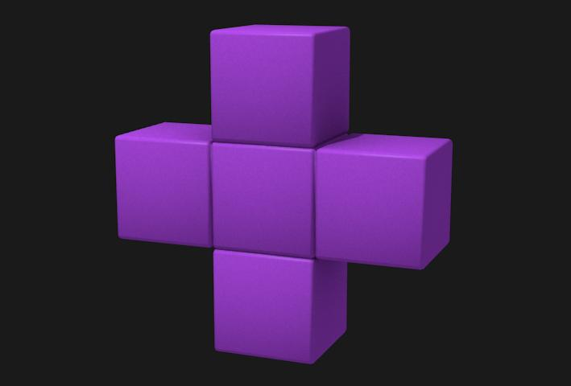
Step 1: Calculate the total number of cubes.
$$N=1+4=5$$
Step 2: Calculate the volume of one cube.
$$V=s^{3}$$
$$V=3^{3}=27{ cm}^{3}$$
Step 3: Calculate the total volume.
$$V_{total}=5×27$$
$$\boxed{V_{total}=135{ cm}^{3}}$$
Step 4: Calculate the external surface area.
The initial surface area of all five cubes is:
$${SA}_{initial}=5(6×3^{2})$$
$$=270{ cm}^{2}$$
There are four shared square interfaces:
$$A_{interface}=3^{2}=9{ cm}^{2}$$
Therefore:
$${SA}_{external}=270-2(4×9)$$
$$\boxed{{SA}_{external}=198{ cm}^{2}}$$
Step 5: Determine the symmetry.
The arrangement has reflectional symmetry across:
- A vertical plane dividing the left and right components.
- A vertical plane dividing the front and back components.
- A horizontal plane passing through the middle of the cubes.
Therefore, it has multiple planes of symmetry.

Example 2: Rotationally Symmetrical Arrangement of Cylinders
# Source: AI Source: Provided by: [Data Path: Persons Table -> ID Column: 1, Name_En Column: Motasem Essam] -> From: [ChatGPT] on [7/25/2026]
Problem:
A composite solid consists of one central cylinder surrounded by six identical cylinders. Each cylinder has:
- Radius = 2 cm.
- Height = 5 cm.
The six outer cylinders are distributed uniformly around the central cylinder and positioned without overlapping.
Calculate:
- The total number of cylinders.
- The total volume.
- The angular separation.
- The rotational symmetry angle.
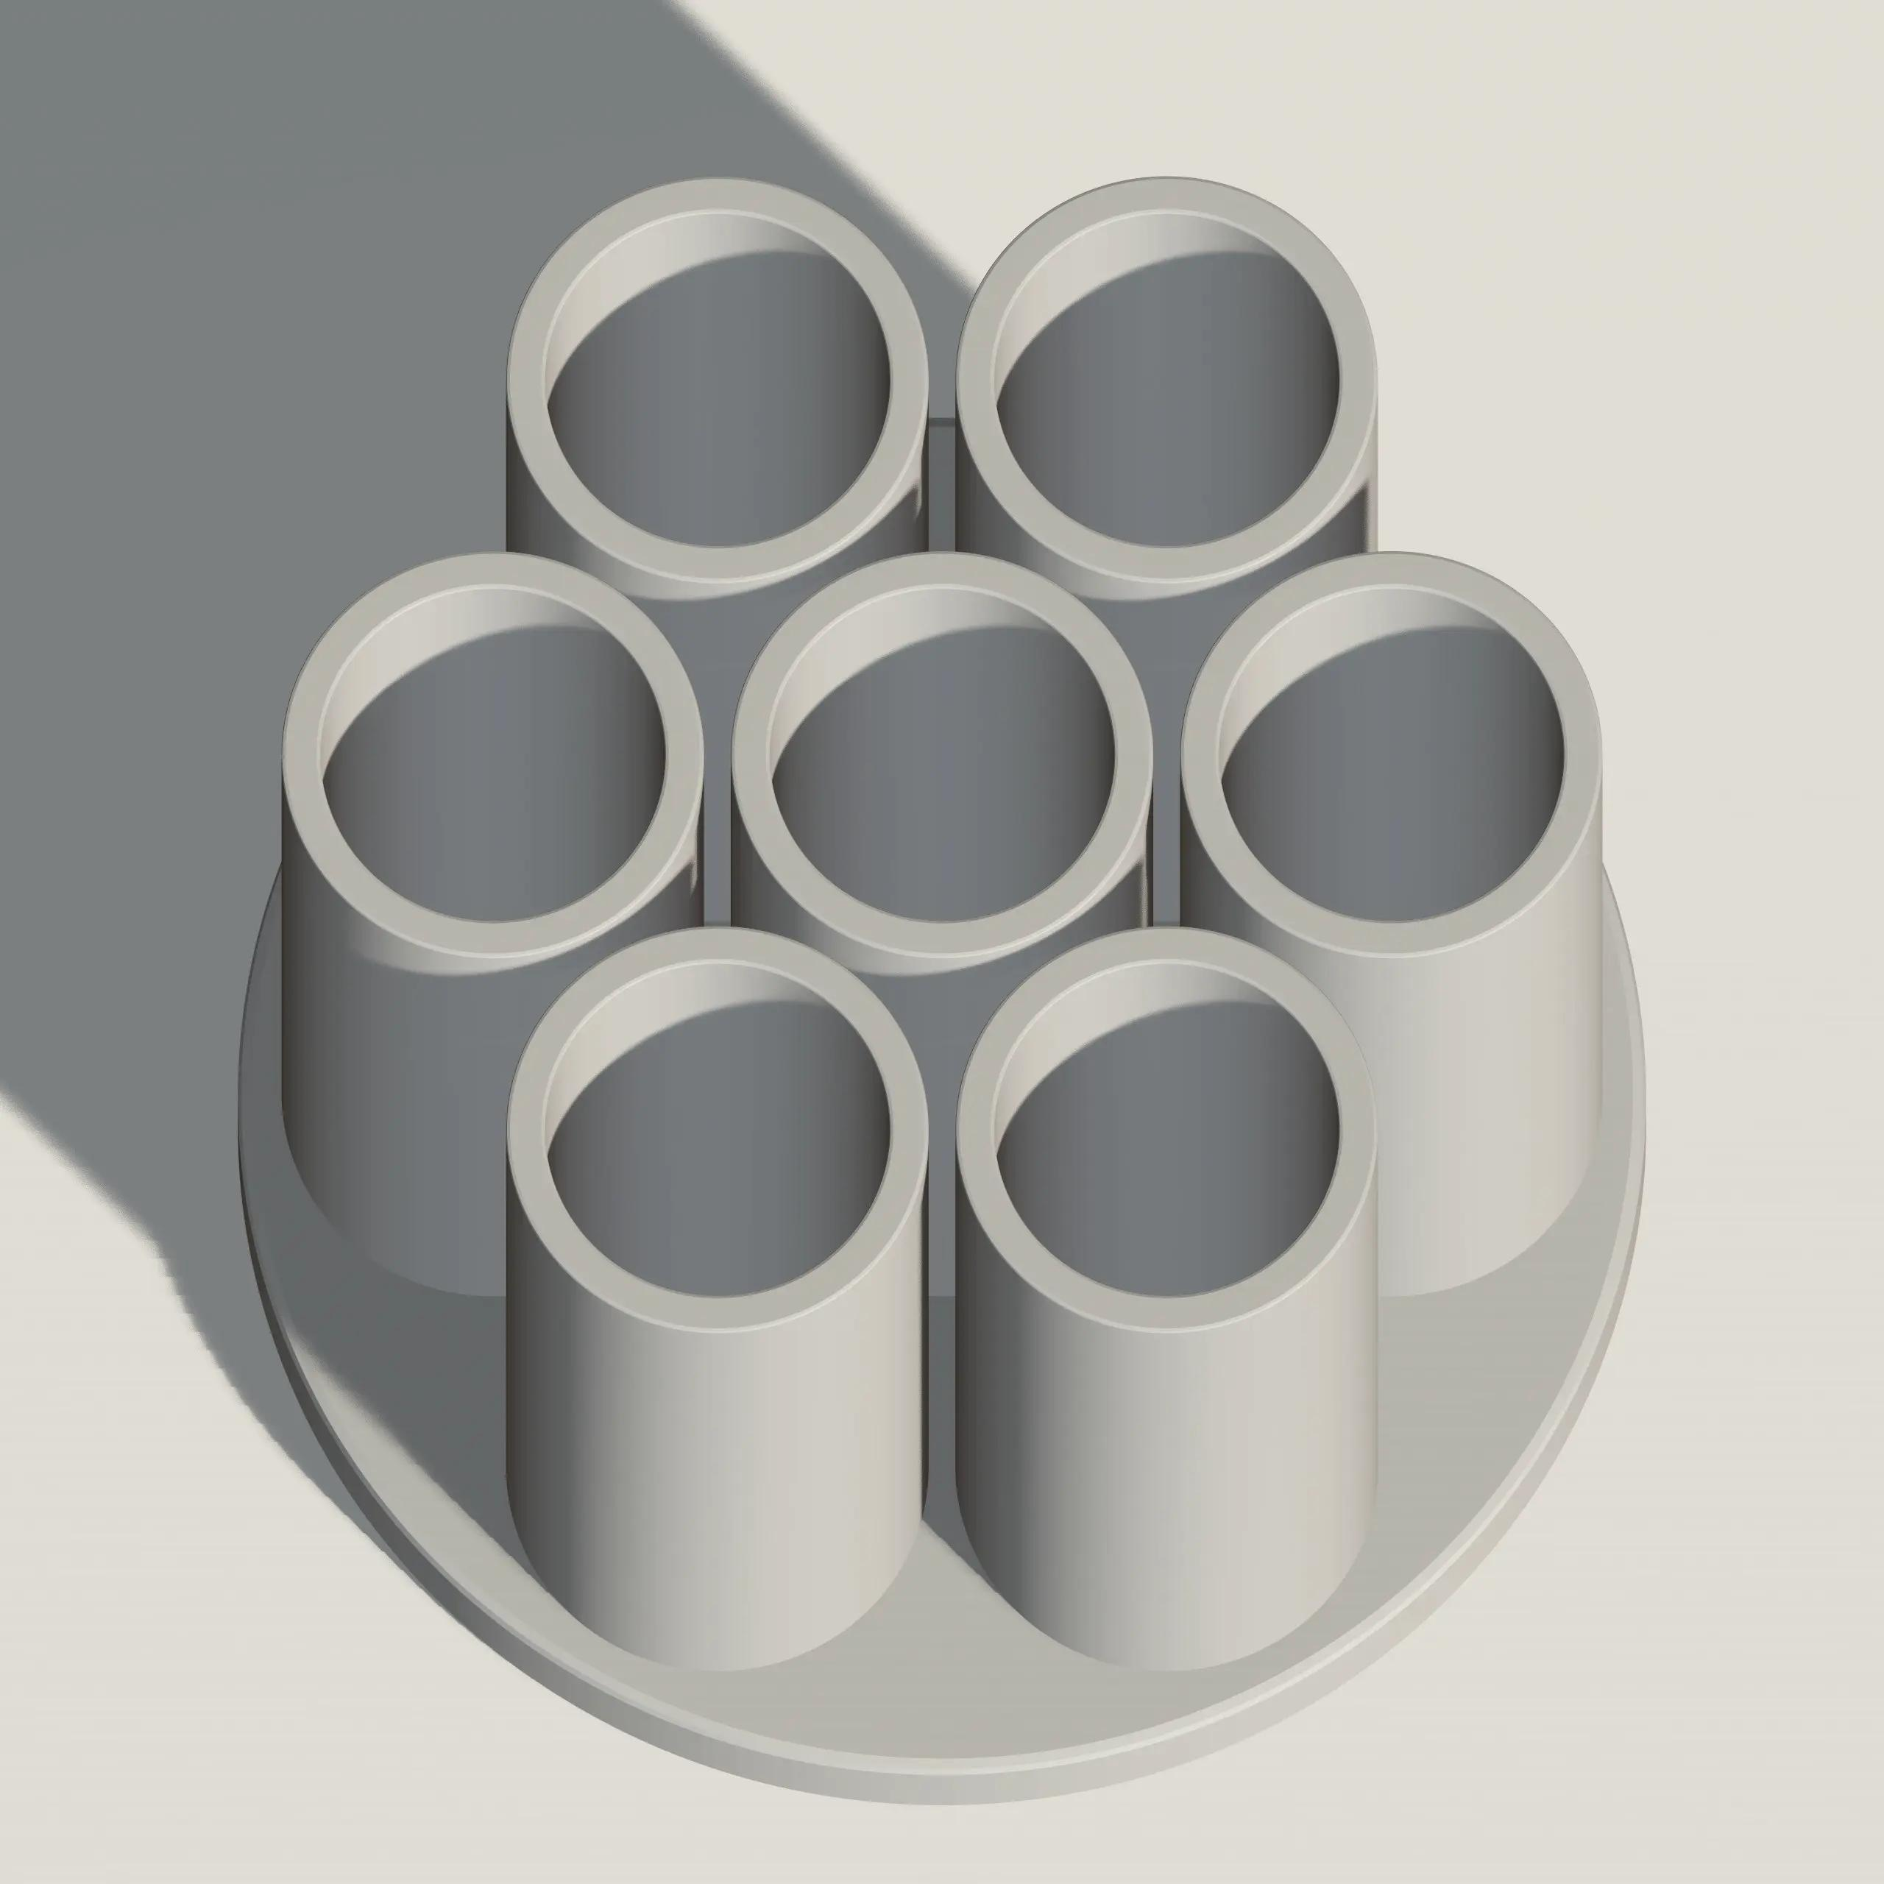
Step 1: Calculate the total number of cylinders.
$$N=1+6=7$$
Step 2: Calculate the volume of one cylinder.
$$V=πr^{2}h$$
$$V=π(2)^{2}(5)$$
$$V=20π{ cm}^{3}$$
Step 3: Calculate the total volume.
$$V_{total}=7(20π)$$
$$\boxed{V_{total}=140π≈439.82{ cm}^{3}}$$
Step 4: Calculate the angular separation.
$$θ=\frac{{360}^{∘}}{6}$$
$$\boxed{θ={60}^{∘}}$$
Step 5: Determine the rotational symmetry.
The arrangement repeats after each rotation of ${60}^{∘}$ around its central vertical axis.
Therefore, it has sixfold rotational symmetry.

Important Characteristics
# Source: AI Source: Provided by: [Data Path: Persons Table -> ID Column: 1, Name_En Column: Motasem Essam] -> From: [ChatGPT] on [7/25/2026]
- Components follow a symmetrical spatial distribution.
- Symmetry may be based on a plane, axis, or central point.
- Corresponding components must have matching geometric properties under the relevant transformation.
- The arrangement may contain one or multiple planes of symmetry.
- Rotational symmetry occurs when the arrangement matches itself after a rotation.
- Components may be identical or different, provided corresponding components match.
- Component orientations may be identical, reflected, or rotationally related.
- Symmetrical arrangements may be combined with radial, layered, or grid arrangements.
- Symmetry does not necessarily mean that all components have equal dimensions.
- The overall symmetry depends on the positions, shapes, dimensions, and orientations of all components.

Comparison with Other Component Arrangements
# Source: AI Source: Provided by: [Data Path: Persons Table -> ID Column: 1, Name_En Column: Motasem Essam] -> From: [ChatGPT] on [7/25/2026]
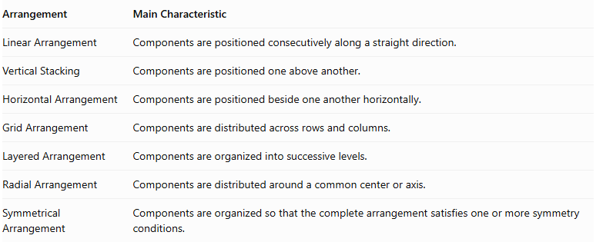
Arrangement | Main Characteristic
Linear Arrangement | Components are positioned consecutively along a straight direction.
Vertical Stacking | Components are positioned one above another.
Horizontal Arrangement | Components are positioned beside one another horizontally.
Grid Arrangement | Components are distributed across rows and columns.
Layered Arrangement | Components are organized into successive levels.
Radial Arrangement | Components are distributed around a common center or axis.
Symmetrical Arrangement | Components are organized so that the complete arrangement satisfies one or more symmetry conditions.
Symmetrical vs. Radial Arrangement: A radial arrangement describes how components are distributed around a center or axis. A symmetrical arrangement describes a geometric property of the complete configuration. A radial arrangement can be symmetrical, but radial distribution alone does not guarantee symmetry.
Symmetrical vs. Layered Arrangement: A layered arrangement describes the vertical organization of components, while a symmetrical arrangement describes the matching relationships between components. A layered structure may also have reflectional or rotational symmetry.

Real-World Applications
# Source: AI Source: Provided by: [Data Path: Persons Table -> ID Column: 1, Name_En Column: Motasem Essam] -> From: [ChatGPT] on [7/25/2026]
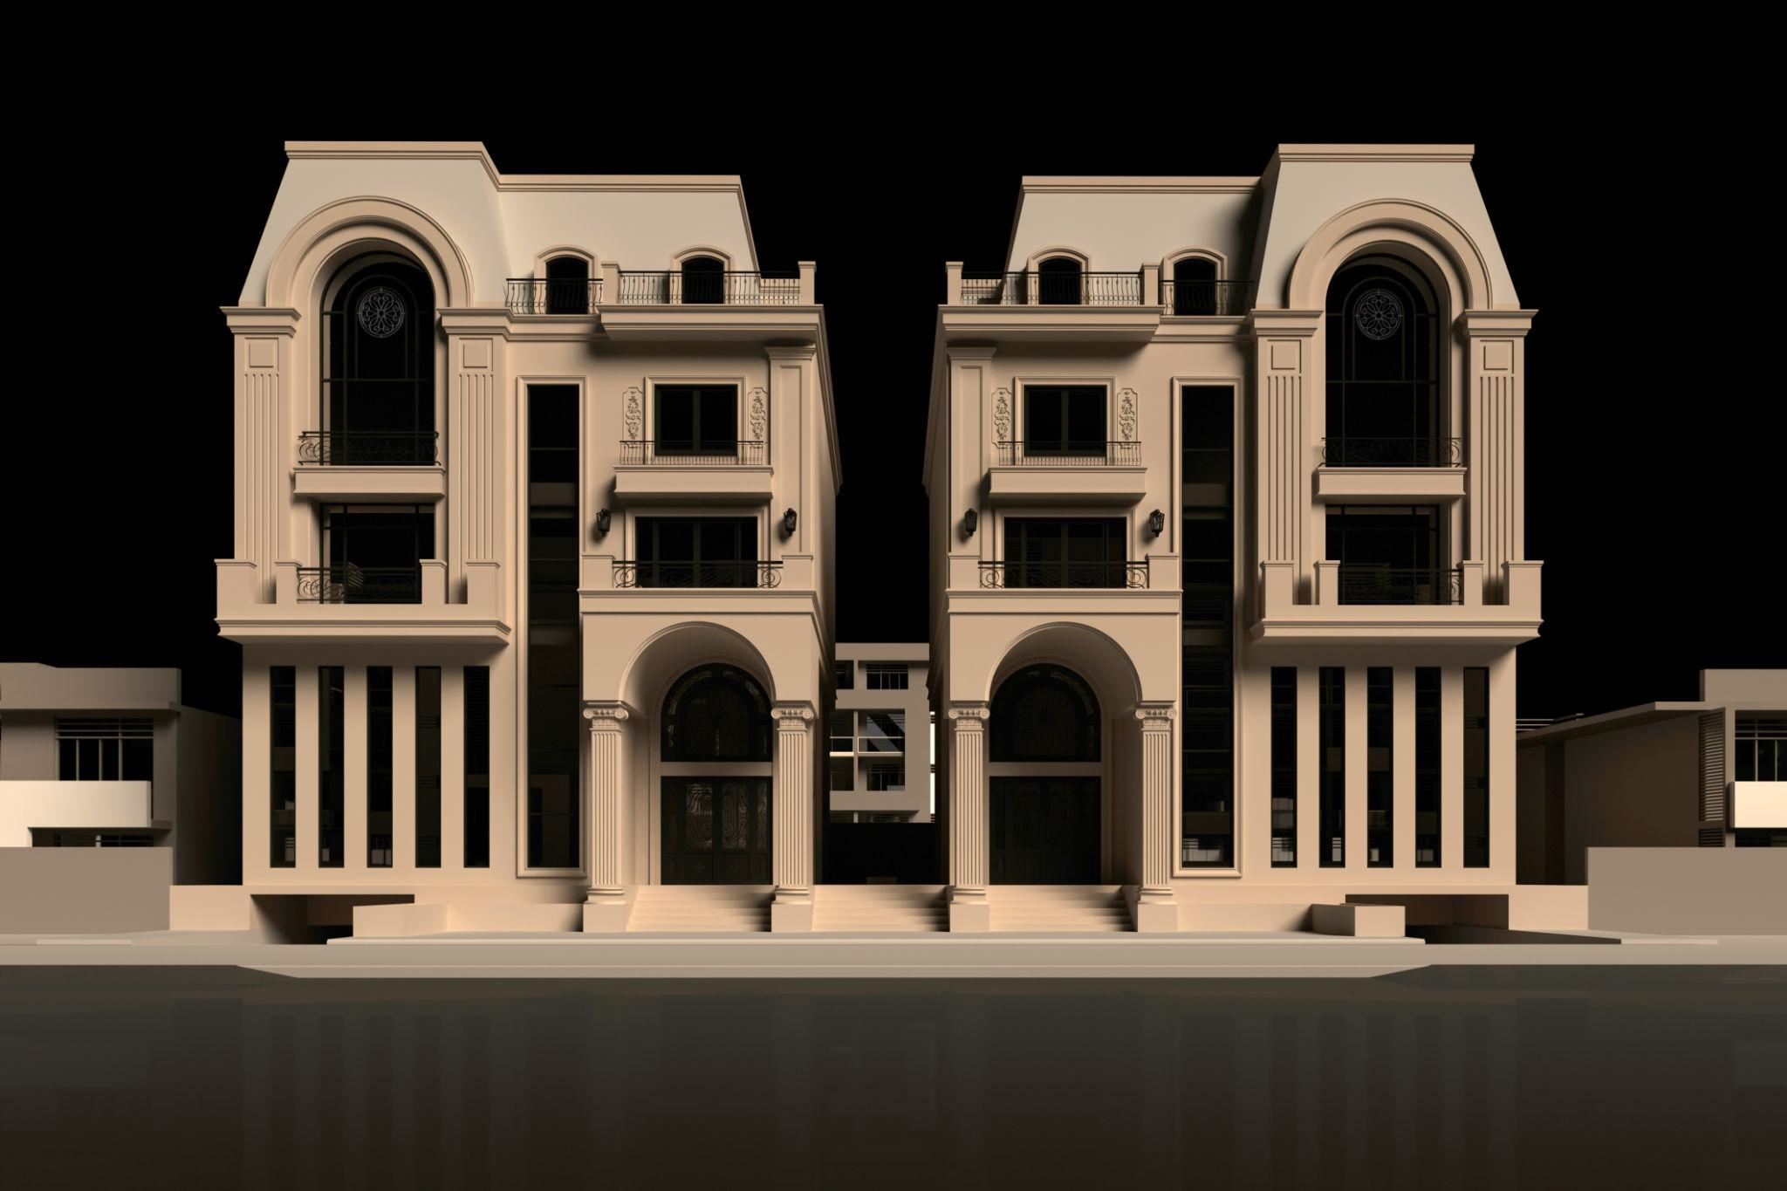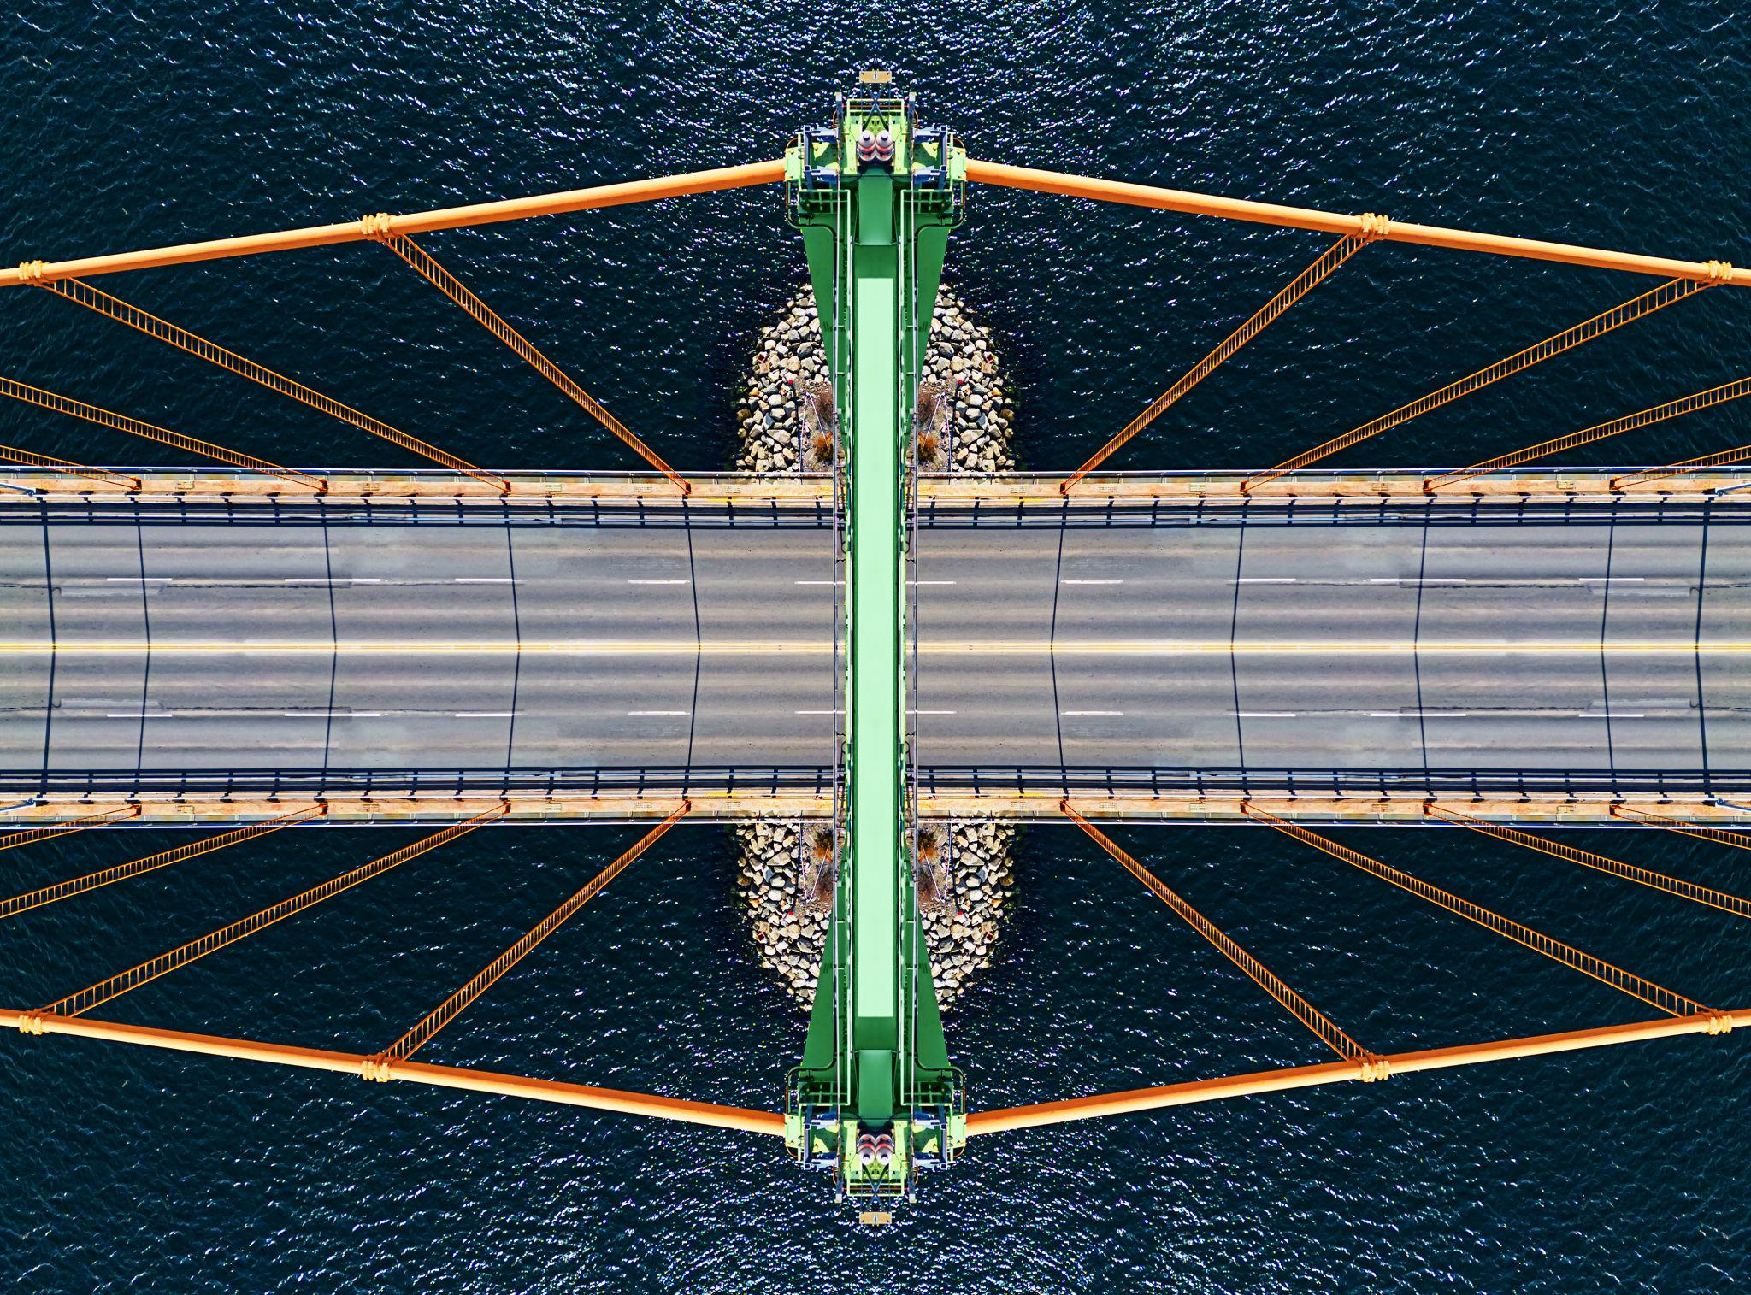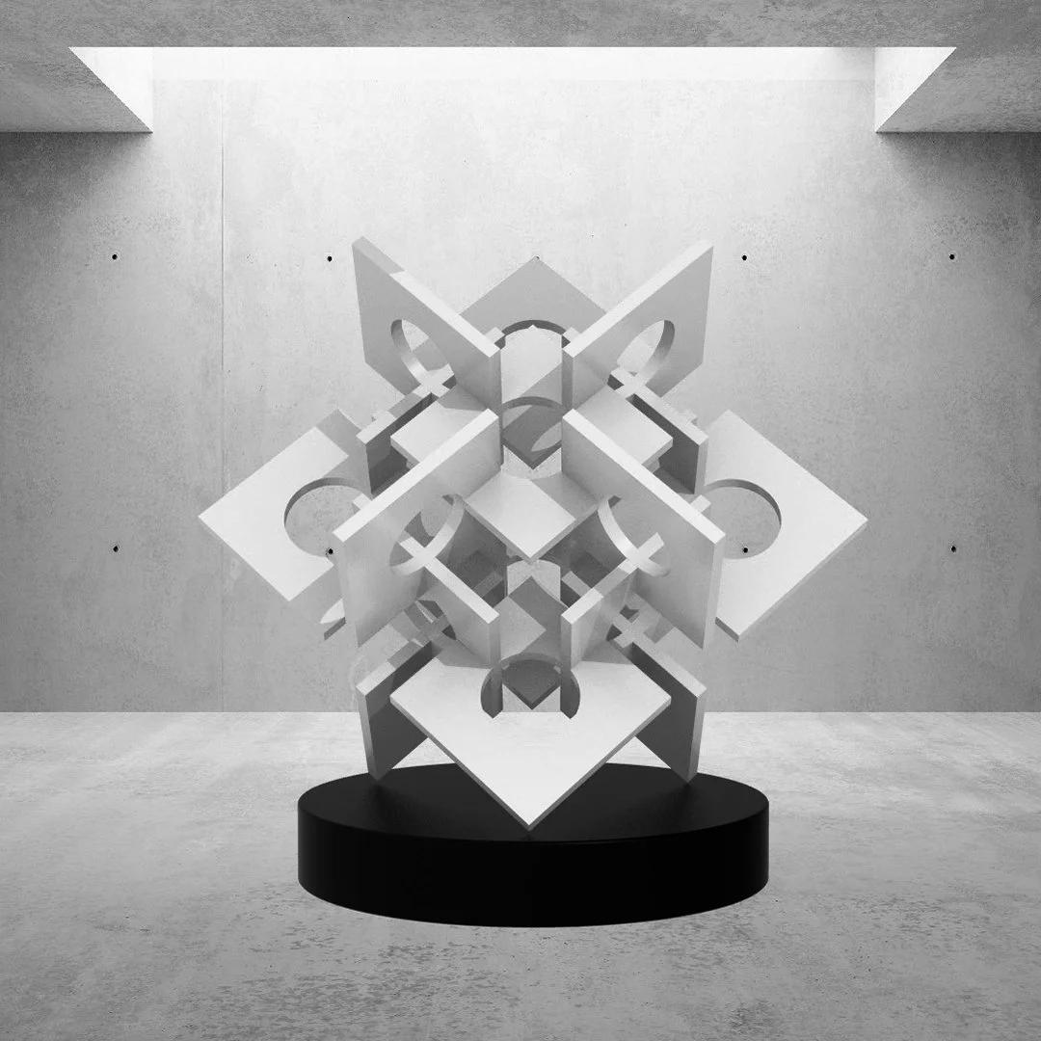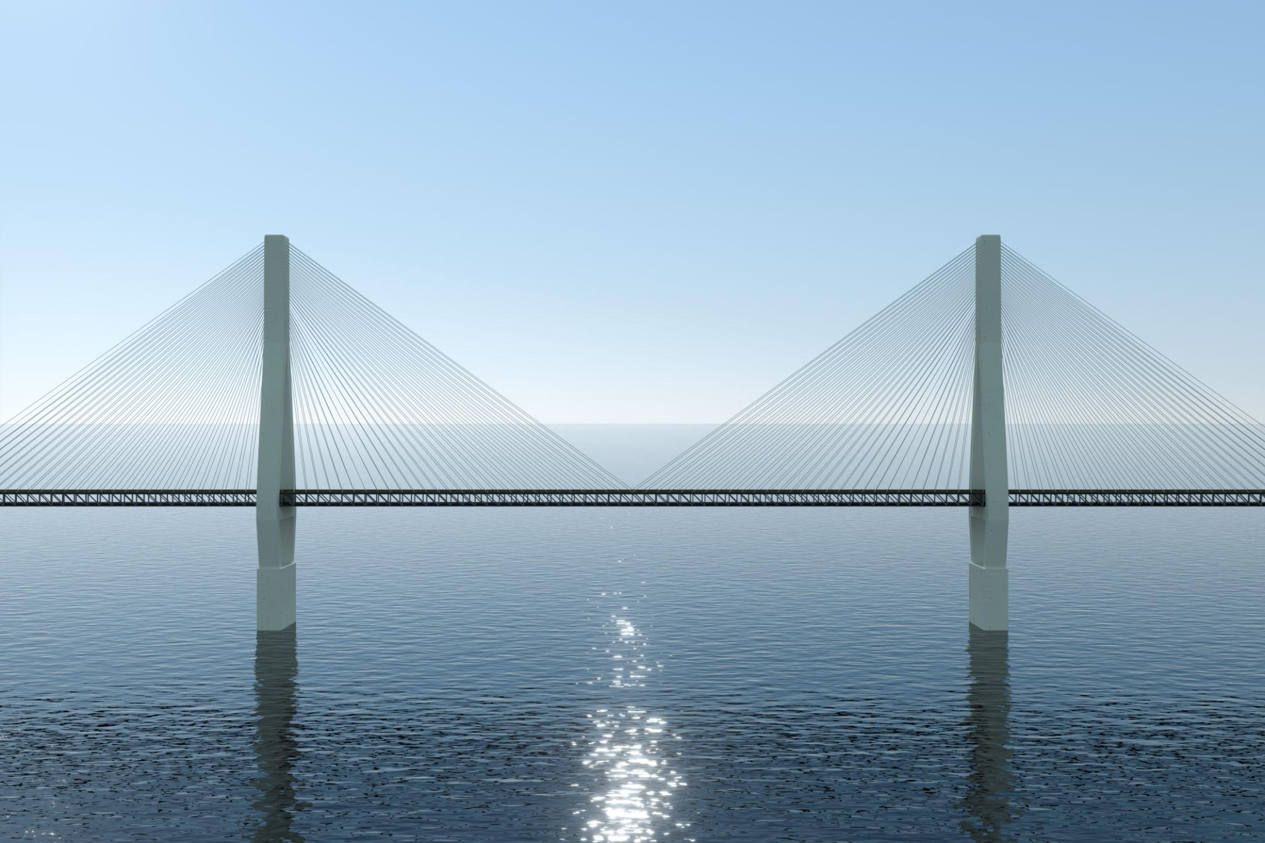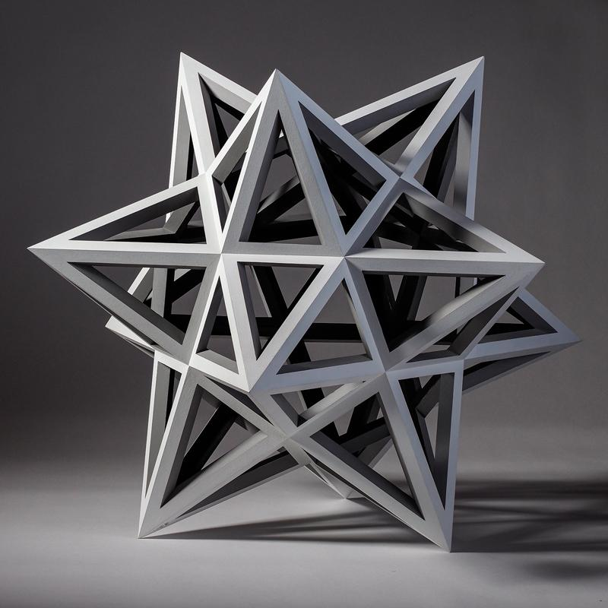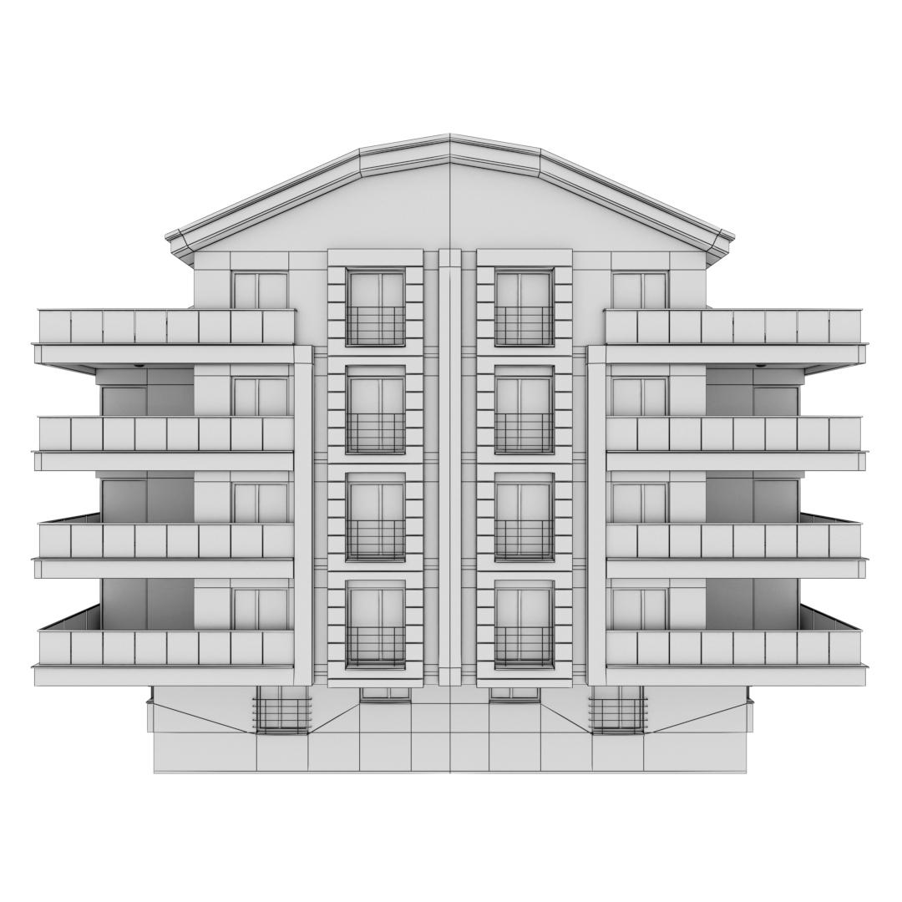
- Architecture: Symmetrical buildings, columns, and structural arrangements.
- Mechanical Engineering: Balanced mechanical assemblies and rotating mechanisms.
- Construction: Symmetrical structural supports and frameworks.
- Industrial Design: Symmetrical product components and machine layouts.
- Sculpture: Three-dimensional geometric compositions with balanced forms.
- Mathematics: Studying reflectional symmetry, rotational symmetry, and spatial transformations.

Key Points
# Source: AI Source: Provided by: [Data Path: Persons Table -> ID Column: 1, Name_En Column: Motasem Essam] -> From: [ChatGPT] on [7/25/2026]
- A symmetrical arrangement organizes components according to matching geometric relationships.
- Symmetry may be reflectional, rotational, or central.
- Components may be distributed around planes, axes, or central points.
- Corresponding components must match under the relevant transformation.
- Equal component dimensions are not required for every arrangement.
- Radial and layered arrangements can also exhibit symmetry.
- Symmetry is determined by the complete configuration, not simply by the number of components.

Conclusion
# Source: AI Source: Provided by: [Data Path: Persons Table -> ID Column: 1, Name_En Column: Motasem Essam] -> From: [ChatGPT] on [7/25/2026]
A Symmetrical Arrangement is a classification of composite solids based on the geometric balance and matching relationships between their components. The components are positioned so that the complete structure exhibits reflectional, rotational, central, or combined symmetry.
It is useful for describing three-dimensional structures with balanced distributions, matching component positions, and repeated geometric patterns.

